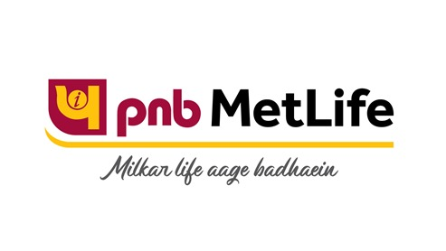

Coverage Report
On
PNB METLIFE
Updated on: August 31, 2020

BROADCAST

No. | Publication/Portal | Headline | Date
1 | CNBC TV 18 | Ashish Kumar Shrivastava’s Panel Discussion | August 8 , 2020

Publication : CNBC TV 18 | Edition : Online
Date : August 8,2020 | Headline: Ashish Kumar Shrivastava’s Panel Discussion



WIRES

No. | Publication/Portal | Headline | Date
1 | Press Trust of India |  | August 4 , 2020
2 | United News of India |  | August 3 , 2020

Publication : Press Trust of India | Edition : Online
Date : August 4,2020 | Headline: Insurer PNB MetLife launches 3 offerings for retail customers


Insurer PNB MetLife launches 3 offerings for retail customers

Insurer PNB MetLife on Tuesday said it has launched three new offerings aimed at retail customers.
The offerings are aimed to help with child education, family protection and also provide long-term savings, according to an official statement.

Publication : United News of India | Edition : Online
Date : August 4,2020 | Headline: PNB MetLife broadens its product portfolio with three unique offerings for retail customers

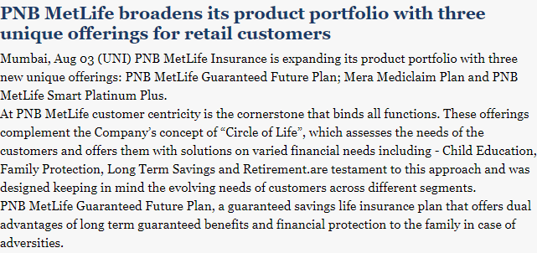

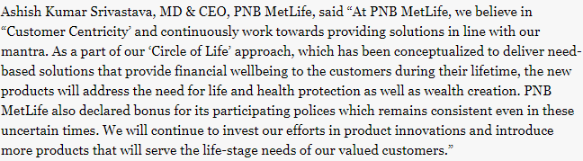
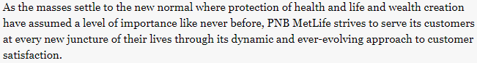

PRINT

No. | Publication/Portal | Headline | Date
1 | The Hindu | Life insurance term plan premium | August 03, 2020
2 | Arthik Lipi | PNB MetLife broadens its product portfolio with three unique offerings for retail customers | August 04, 2020
3 | Echo Of India | PNB MetLife broadens product portfolio | August 04, 2020
4 | Bheema Vijaya | PNB MetLife India Life Insurance | August 04, 2020
5 | Samyukta Karnataka | PNB MetLife India Life Insurance | August 04, 2020
6 | Vishwavani | PNB MetLife India Life Insurance | August 04, 2020
7 | The Statesman | PNB MetLife | August 05, 2020
8 | Satellite Samachar | PNB MetLife broadens its product portfolio with three unique offerings for retail customers | August 05, 2020
9 | Standard Herald | PNB MetLife broadens its product portfolio with three unique offerings for retail customers | August 05, 2020
10 | Morning India | PNB MetLife broadens product portfolio | August 05, 2020
11 | Business Remedies | PNB MetLife expands its product portfolio with three unique offers for retail customers | August 05, 2020
12 | Adhikar | PNB MetLife expands its product portfolio with three unique offers for retail customers | August 05, 2020
13 | Jalte Deep | PNB MetLife expands its product portfolio with three unique offers for retail customers | August 05, 2020
14 | Kanchan Kesari | PNB MetLife expands product portfolio | August 05, 2020
15 | Hosadigantha | PNB MetLife India | August 05, 2020
16 | Dina Thodar | PNB MetLife India Life | August 05, 2020
17 | Simhadhwani | PNB MetLife India Life Insurance | August 05, 2020
18 | Amogha Vani | PNB MetLife India Life Insurance Life | August 05, 2020
19 | Aajkaal | PNB MetLife broadens its product portfolio with three unique offerings for retail customers | August 06, 2020
20 | Awaz Plus | PNB MetLife expands its product portfolio with three unique offers for retail customers | August 06, 2020
21 | Rashtriya Prastavana | PNB MetLife expands its product portfolio with three unique offers for retail customers | August 06, 2020
22 | Hindustan | PNB MetLife expands new delhi | August 06, 2020
23 | Swatantra Bharat | PNB MetLife expands portfolio | August 06, 2020
24 | Morning India | Technovision-2020 for Financial Services from Capgemini | August 06, 2020
25 | Rashtriya Sahara | Three new products of PNB MetLife | August 06, 2020
26 | Mint | Nominees have first right over life insurance claims, not legal heirs | August 07, 2020
27 | Sanjevani | PNB MetLife India Life Insurance | August 07, 2020
28 | The Hindu Business Line | PNB MetLife launches Guaranteed Future Plan | August 07, 2020
29 | Trinity Mirror | PNB MetLife broadens its product portfolio | August 08, 2020
30 | Hello Madras | PNB MetLife broadens its product portfolio with three unique offerings for retail customers | August 08, 2020
31 | Karnavati Express | PNB MetLife broadens its product portfolio with three unique offerings for retail customers | August 08, 2020
32 | Suryakaal | PNB MetLife broadens its product portfolio with three unique offerings for retail customers | August 08, 2020
33 | Nishpaksh Divya Sandesh | PNB MetLife expands portfolio | August 08, 2020
34 | Vanakkam Tamilagam | PNB MetLife India Life Insurance | August 08, 2020
35 | Makkal Kural | PNB MetLife India Life Insurance | August 09, 2020
36 | Aaj | PNB MetLife expands product portfolio | August 11, 2020
37 | Hello Madras (Tamil) | PNB MetLife India Life Insurance | August 11, 2020
38 | The Economic Times Wealth | Product Launches | August 17, 2020

Publication : The Hindu | Edition : Bangalore, Chennai, Coimbatore, Hyderabad, Kochi, Mumbai , Noida
Date : August 03, 2020 | Page: 13
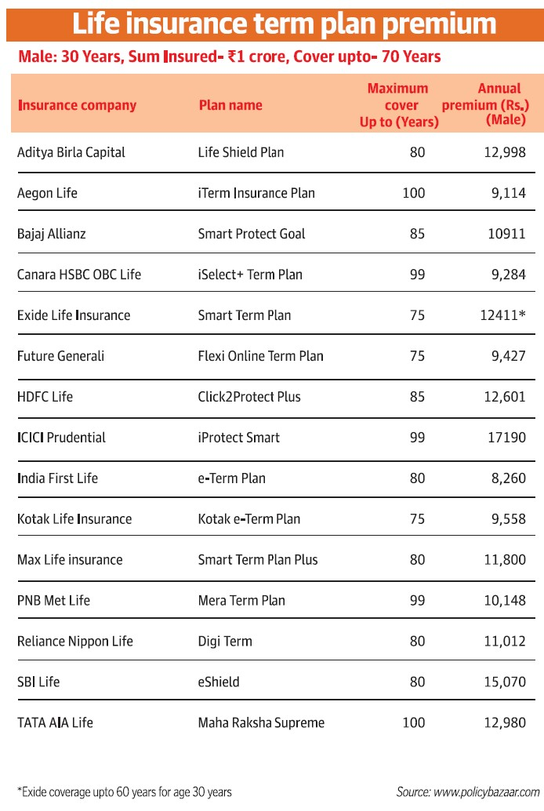

Publication : Arthik Lipi | Edition : Kolkata
Date : August 04, 2020 | Page: 9
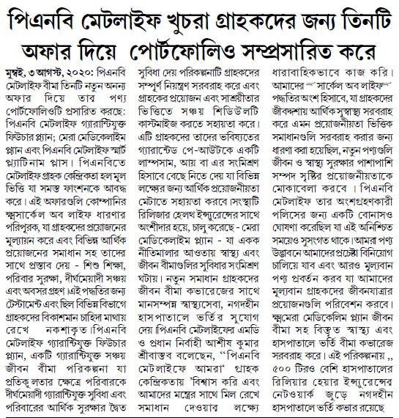

Publication : Echo Of India | Edition : Kolkata
Date : August 04, 2020 | Page: 8
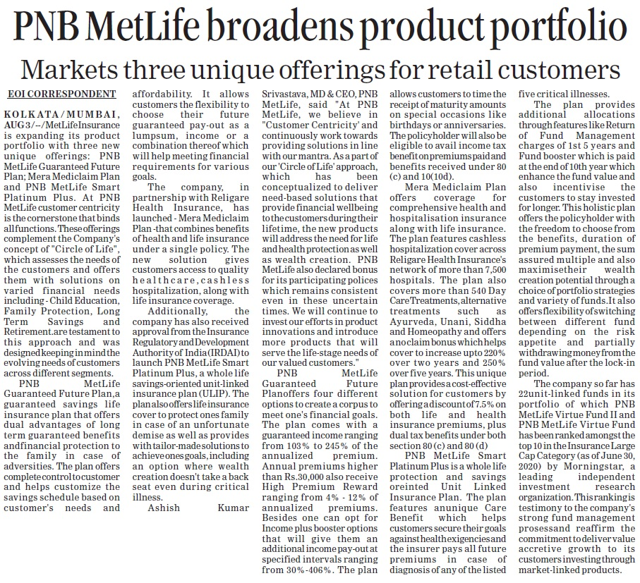

Publication : Bheema Vijaya | Edition : Bangalore
Date : August 04, 2020 | Page: 2
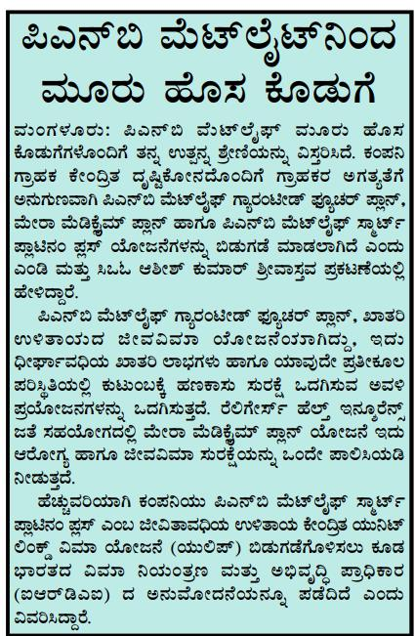

Publication : Samyukta Karnataka | Edition : Bangalore
Date : August 04, 2020 | Page: 2
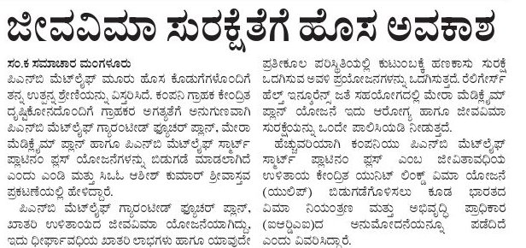

Publication : Vishwavani | Edition : Bangalore
Date : August 04, 2020 | Page: 7
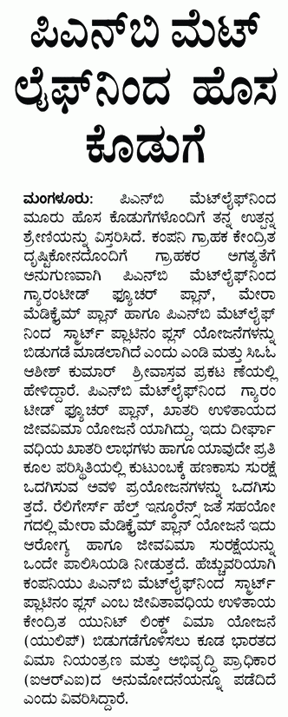

Publication : The Statesman | Edition : Bhubaneswar, Siliguri, New Delhi, Kolkata
Date : August 05, 2020 | Page: 8
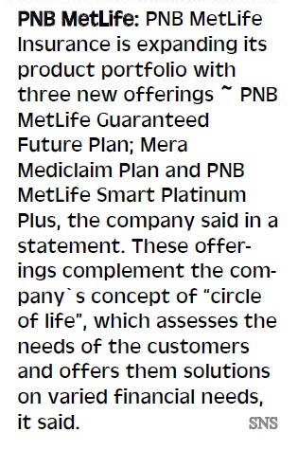

Publication : Satellite Samachar | Edition : Ahmedabad
Date : August 05, 2020 | Page: 3
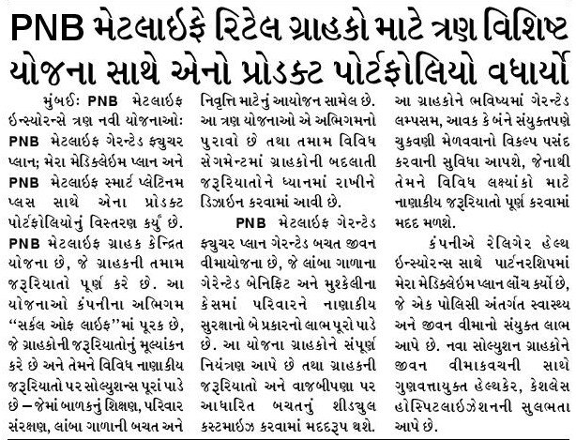

Publication : Standard Herald | Edition : Ahmedabad
Date : August 05, 2020 | Page: 7
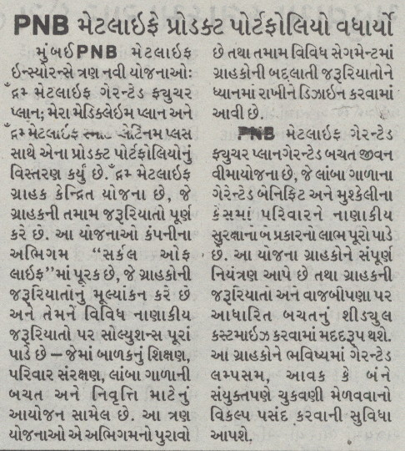

Publication : Morning India | Edition : Kolkata
Date : August 05, 2020 | Page: 3
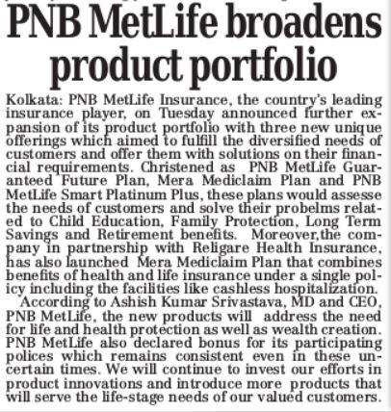

Publication : Business Remedies | Edition : Jaipur
Date : August 05, 2020 | Page: 6
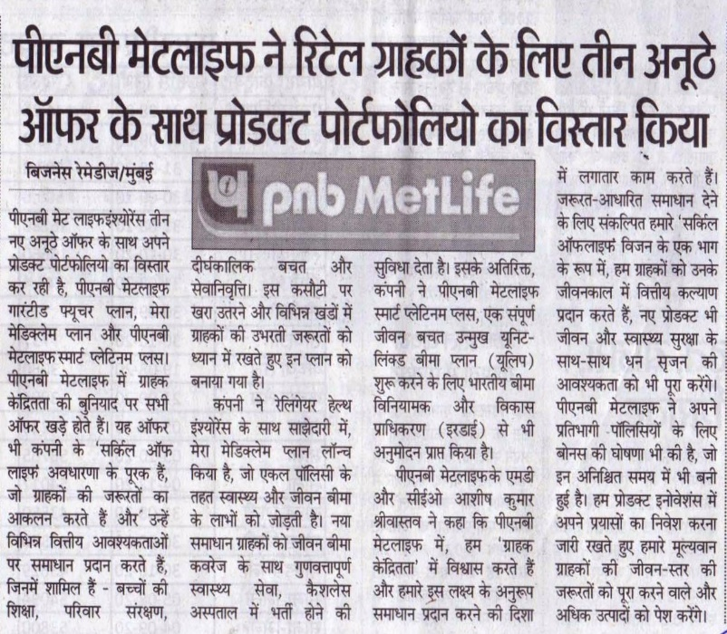

Publication : Adhikar | Edition : Jaipur
Date : August 05, 2020 | Page: 5
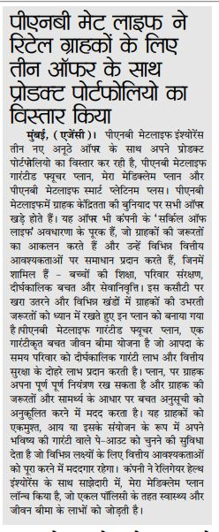

Publication : Jalte Deep | Edition : Jaipur
Date : August 05, 2020 | Page: 7


Publication : Kanchan Kesari | Edition : Jaipur
Date : August 05, 2020 | Page: 7
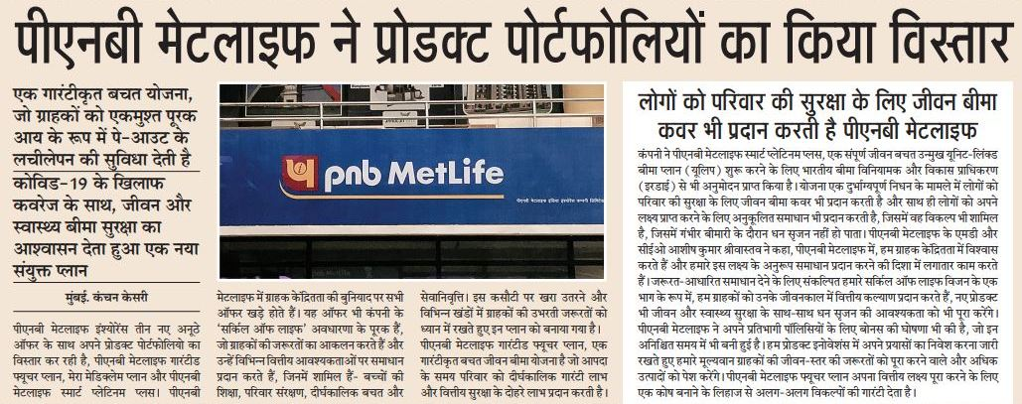

Publication : Hosadigantha | Edition : Bangalore
Date : August 05, 2020 | Page: 8


Publication : Dina Thodar | Edition : Bangalore
Date : August 05, 2020 | Page: 3
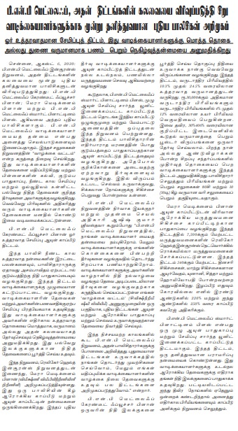

Publication : Simhadhwani | Edition : Bangalore
Date : August 05, 2020 | Page: 3
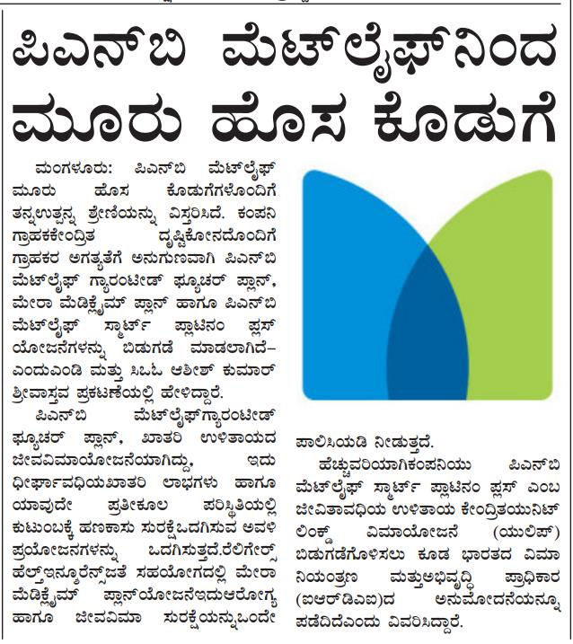

Publication : Amogha Vani | Edition : Bangalore
Date : August 05, 2020 | Page: 3


Publication : Aajkaal | Edition : Kolkata
Date : August 06, 2020 | Page: 8
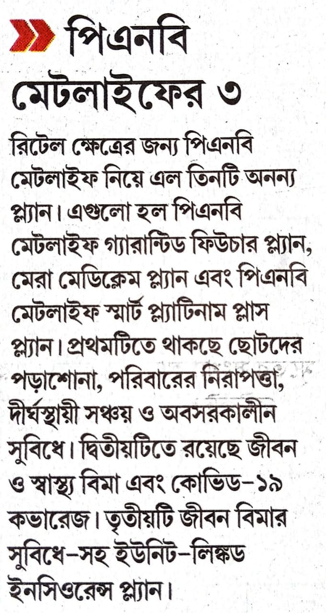

Publication : Awaz Plus | Edition : Lucknow
Date : August 06, 2020 | Page: 7
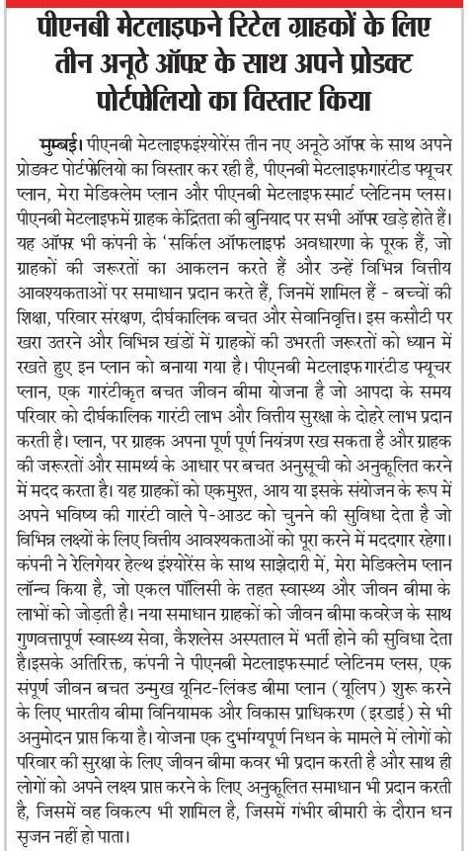

Publication : Rashtriya Prastavana | Edition : Lucknow
Date : August 06, 2020 | Page: 7
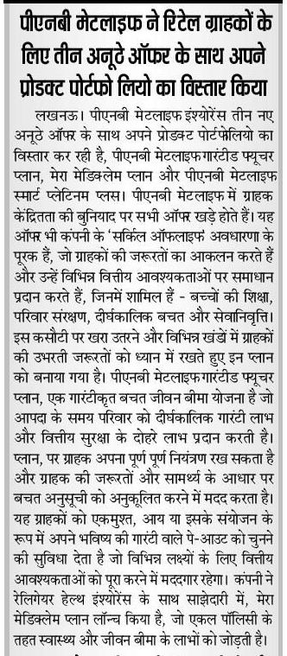

Publication : Hindustan | Edition : Lucknow
Date : August 06, 2020 | Page: 13
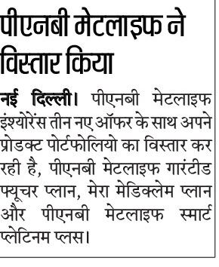

Publication : Swatantra Bharat | Edition : Lucknow
Date : August 06, 2020 | Page: 10
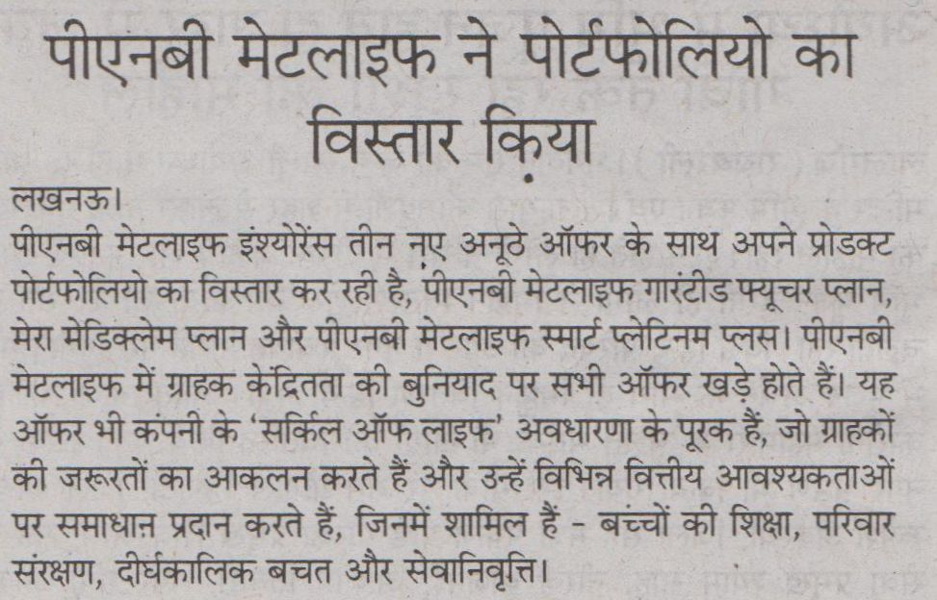

Publication : Morning India | Edition : Kolkata
Date : August 06, 2020 | Page: 3
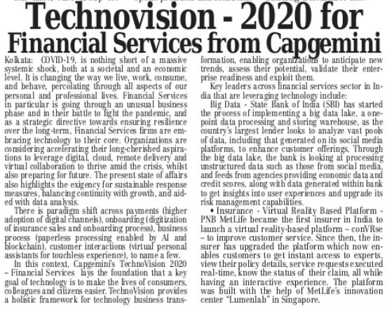

Publication : Rashtriya Sahara | Edition : Lucknow
Date : August 06, 2020 | Page: 12
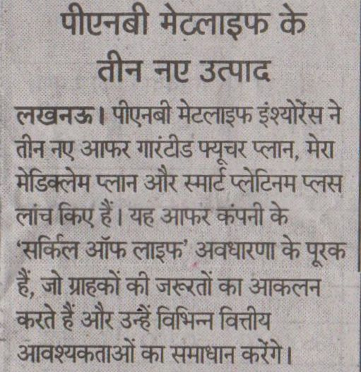

Publication : Mint | Edition : Ahmedabad, New Delhi, Mumbai, Kolkata, Hyderabad, Chennai, Bangalore
Date : August 07, 2020 | Page: 10


Publication : Sanjevani | Edition : Bangalore
Date : August 07, 2020 | Page: 4
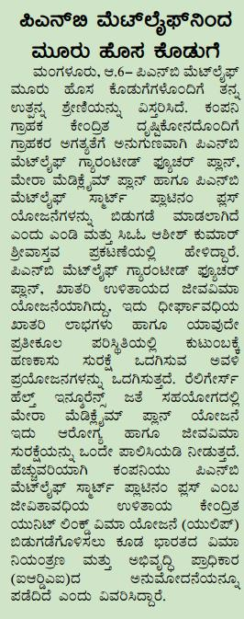

Publication : The Hindu Business Line | Edition : Mumbai
Date : August 07, 2020 | Page: 7
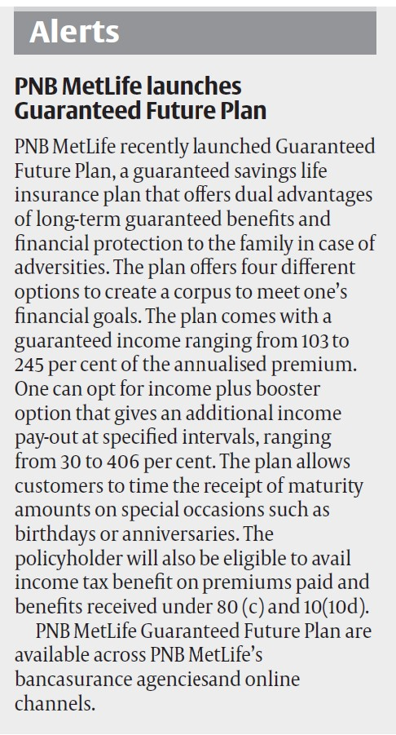

Publication : Trinity Mirror | Edition : Chennai
Date : August 08, 2020 | Page: 3
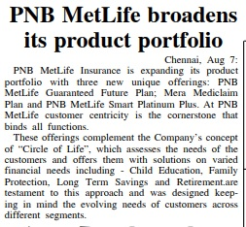

Publication : Hello Madras | Edition : Chennai
Date : August 08, 2020 | Page: 2
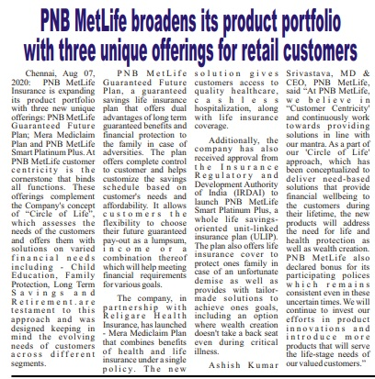

Publication : Karnavati Express | Edition : Ahmedabad
Date : August 08, 2020 | Page: 2
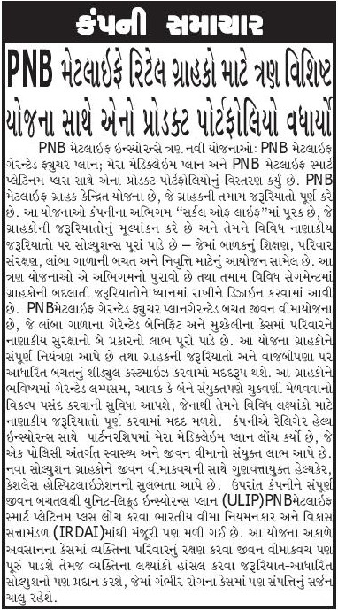

Publication : Suryakaal | Edition : Ahmedabad
Date : August 08, 2020 | Page: 2
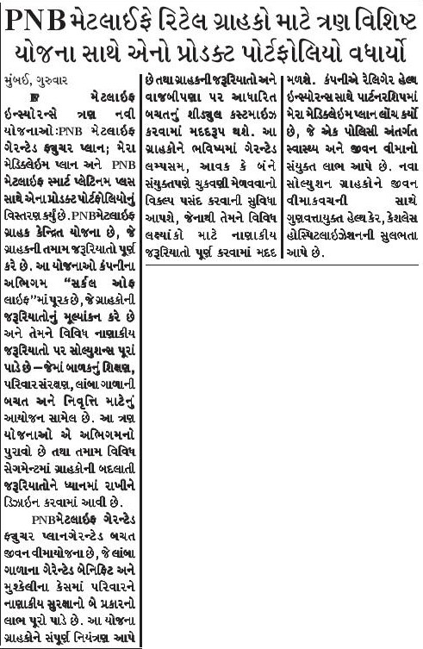

Publication : Nishpaksh Divya Sandesh | Edition : Lucknow
Date : August 08, 2020 | Page: 11
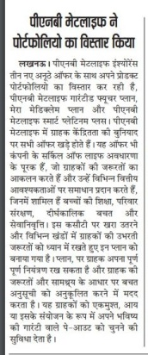

Publication : Vanakkam Tamilagam | Edition : Chennai
Date : August 08, 2020 | Page: 2
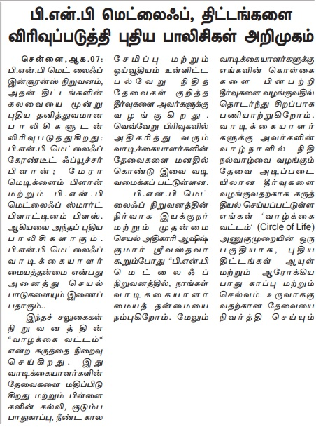

Publication : Makkal Kural | Edition : Chennai
Date : August 09, 2020 | Page: 7
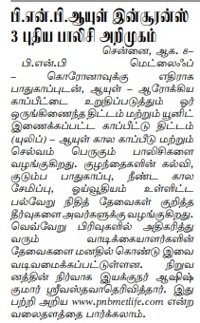

Publication : Aaj | Edition : Lucknow
Date : August 11, 2020 | Page: 9
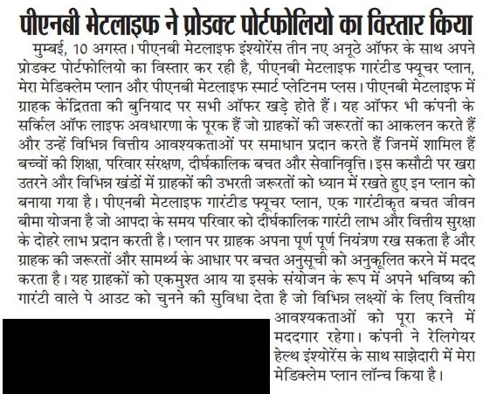

Publication : Hello Madras (Tamil) | Edition : Chennai
Date : August 11, 2020 | Page: 6
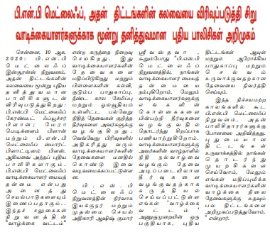

Publication : The Economic Times Wealth | Edition : All
Date : August 17, 2020 | Page: 7
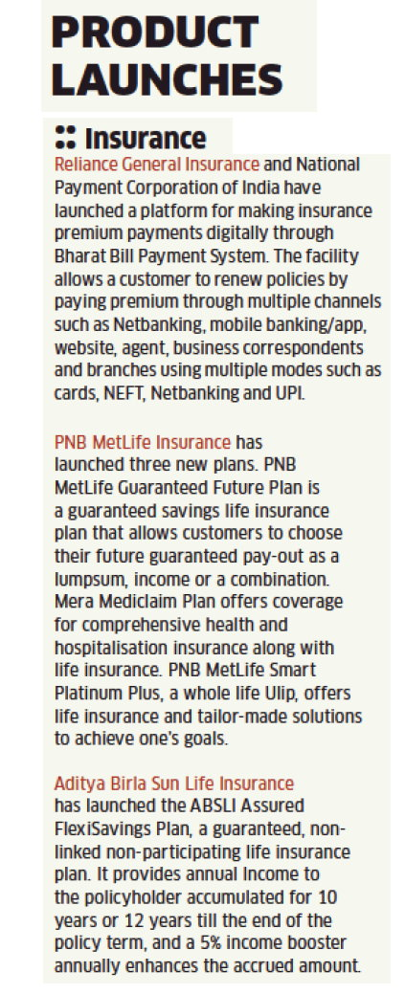

ONLINE

No. | Publication/Portal | Headline | Date
1 | Moneycontrol | PNB MetLife broadens its product portfolio with three unique offerings for retail customers | August 6 ,2020
2 | Navjeevan Express | PNB MetLife broadens its product portfolio with three unique offerings for retail customers | August 4 ,2020
3 | Hybiz TV | PNB MetLife broadens its product portfolio with three unique offerings for retail customers | August 4 ,2020
4 | Latestly | Business briefs 2: PNB MetLife launches 3 offerings for retail customers | August 4 ,2020
5 | Yahoo News | Business briefs 2: PNB MetLife launches 3 offerings for retail customers | August 4 ,2020
6 | Devdiscourse | Business briefs 2: PNB MetLife launches 3 offerings for retail customers | August 4 ,2020
7 | The Financial Express (Online) | Mera Mediclaim plan: Combo of health and life insurance in a single plan-check features | August 3 ,2020
8 | The Hindu Business Line (Online) | PNB MetLife broadens product portfolio with three new products | August 3 ,2020
9 | News Express | PNB MetLife broadens its product portfolio with three unique offerings for retail customers! | August 3 ,2020
10 | CXO Outlook | PNB MetLife broadens its product portfolio with three unique offerings for retail customers | August 3 ,2020
11 | Online and You | PNB MetLife broadens its product portfolio with three unique offerings for retail customers | August 3 ,2020
12 | HR Katha | How PNB MetLife’s workforce is coping with the virtual model | August 1 ,2020

Publication : Moneycontrol | Edition : Online
Date : August 6,2020 | Headline: PNB MetLife broadens its product portfolio with three unique offerings for retail customers


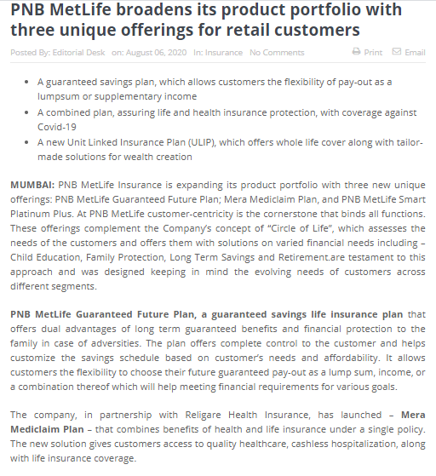

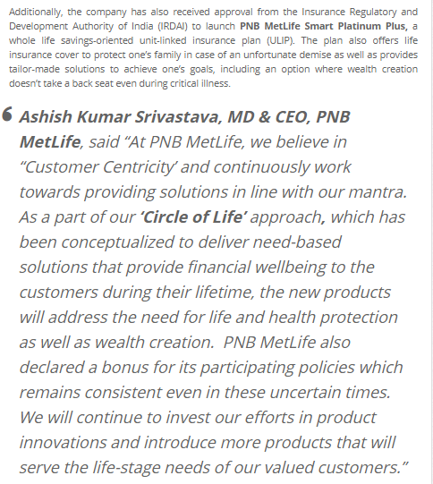
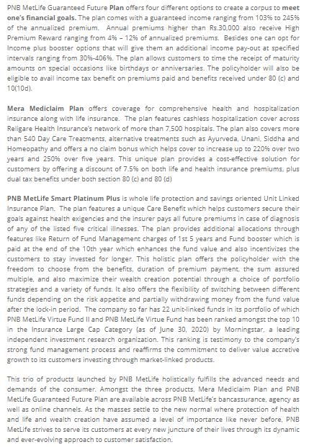
Publication : Navjeevan Express | Edition : Online
Date : August 4,2020 | Headline: PNB MetLife broadens its product portfolio with three unique offerings for retail customers

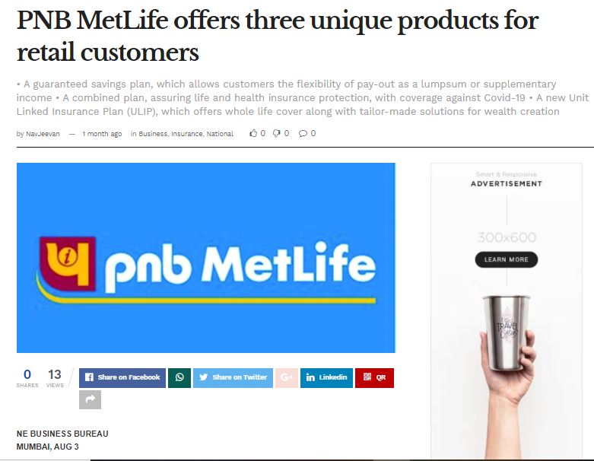

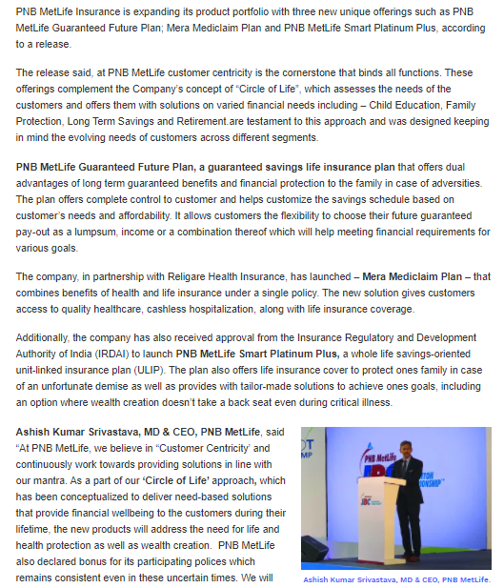

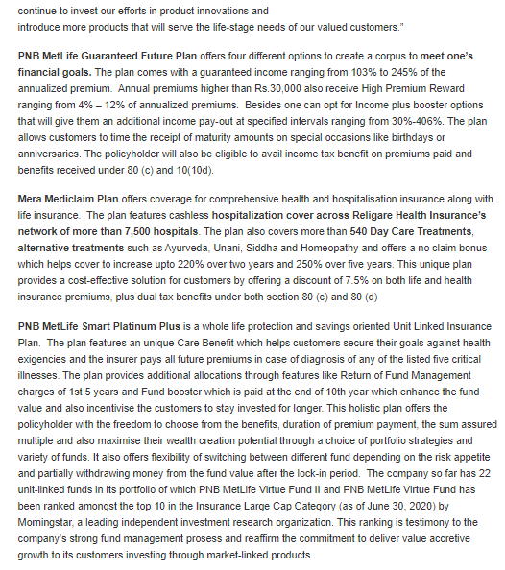

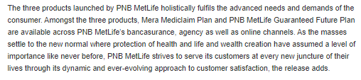
Publication : Hybiz TV | Edition : Online
Date : August 4,2020 | Headline: PNB MetLife broadens its product portfolio with three unique offerings for retail customers


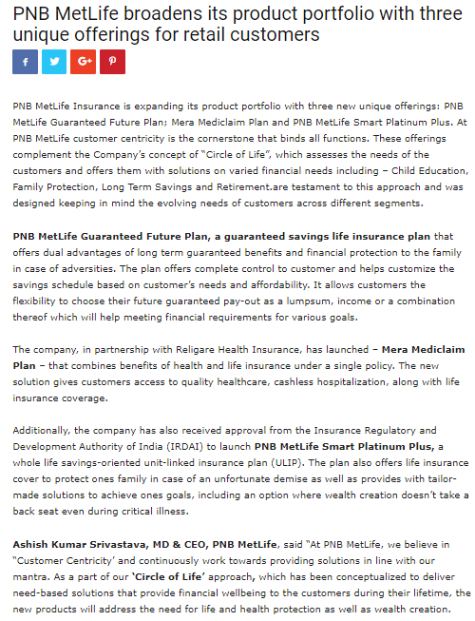


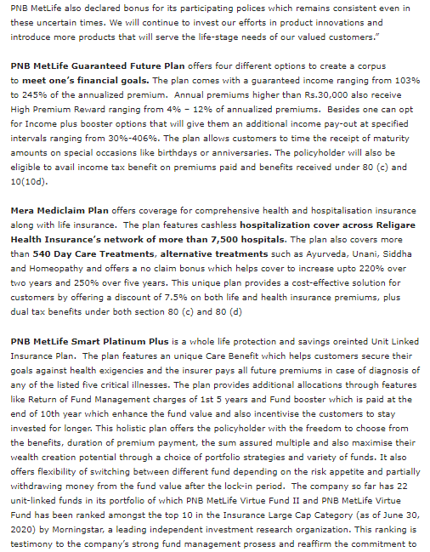

Publication : Latestly | Edition : Online
Date : August 4,2020 | Headline: Business briefs 2: PNB MetLife launches 3 offerings for retail customers

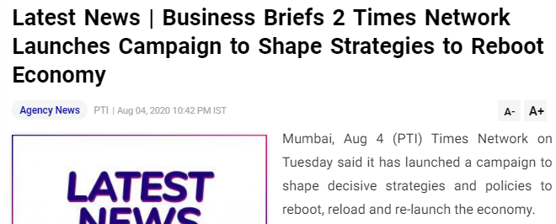

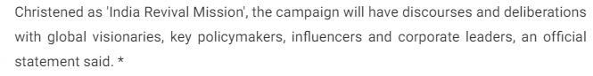
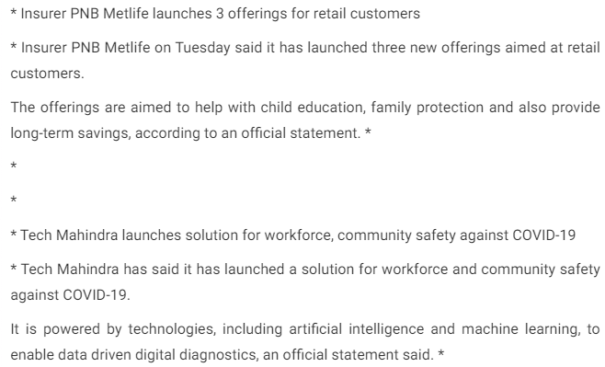

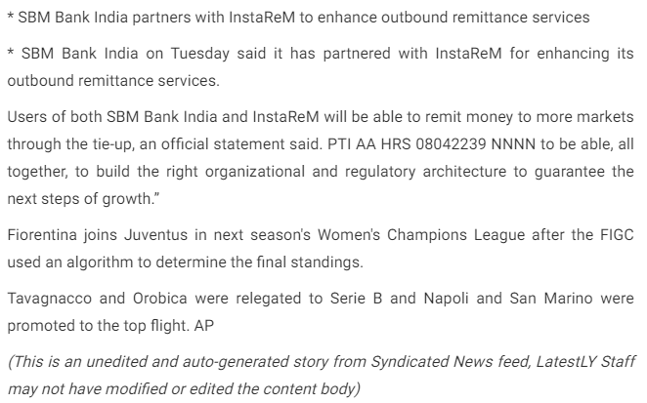

Publication : Yahoo News | Edition : Online
Date : August 4,2020 | Headline: Business briefs 2: PNB MetLife launches 3 offerings for retail customers

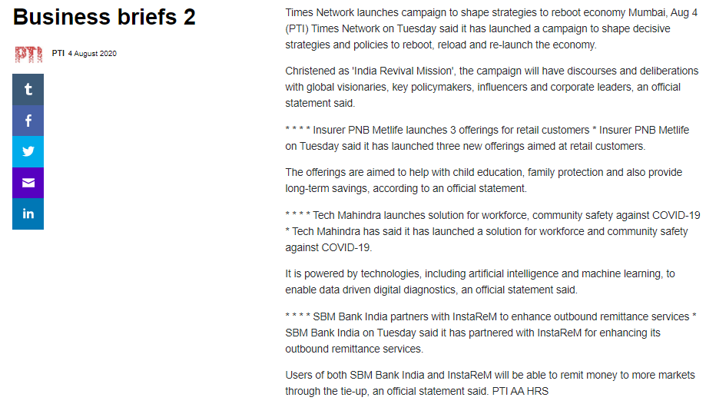

Publication : Devdiscourse | Edition : Online
Date : August 4,2020 | Headline: Business briefs 2: PNB MetLife launches 3 offerings for retail customers


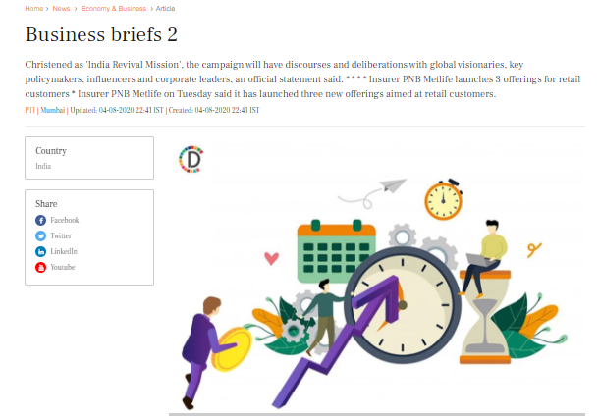

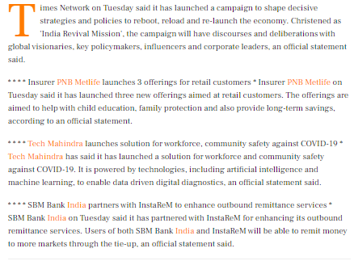

Publication : The Financial Express (Online) | Edition : Online
Date : August 3,2020 | Headline: Mera Mediclaim plan: Combo of health and life insurance in a single plan-check features



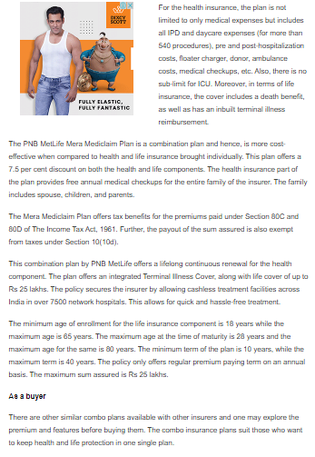

Publication : The Hindu Business Line (Online) | Edition : Online
Date : August 3,2020 | Headline: PNB MetLife broadens product portfolio with three new products

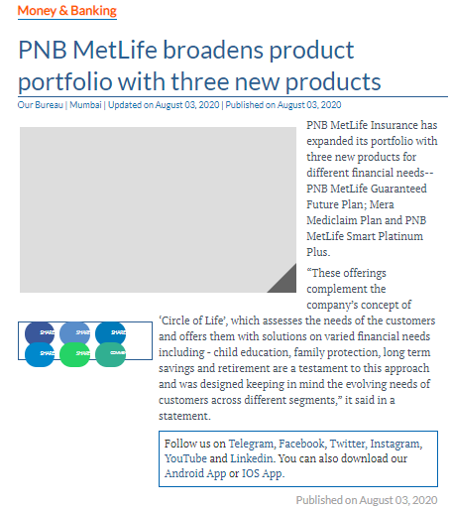


Publication : News Express | Edition : Online
Date : August 3,2020 | Headline: PNB MetLife broadens its product portfolio with three unique offerings for retail customers!

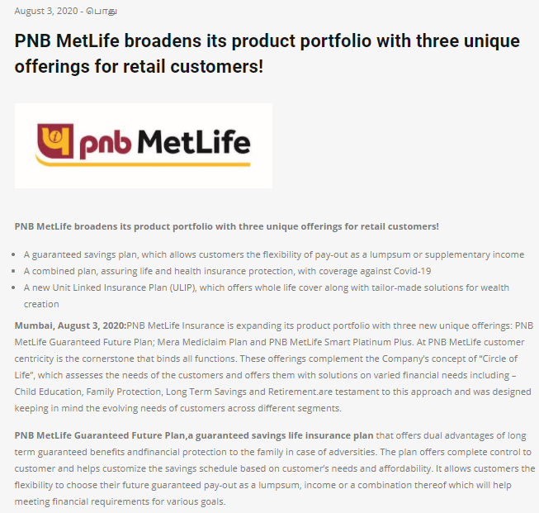

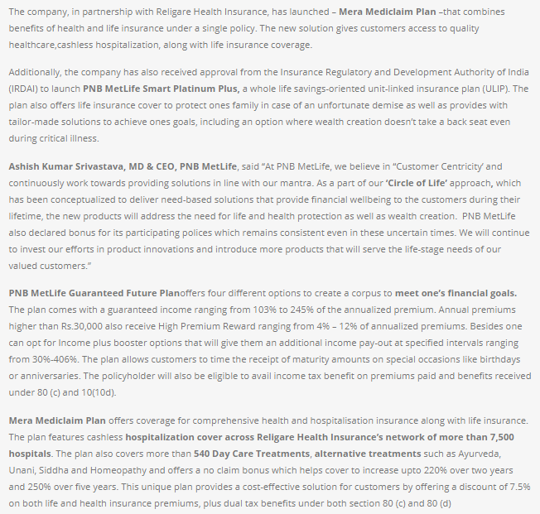

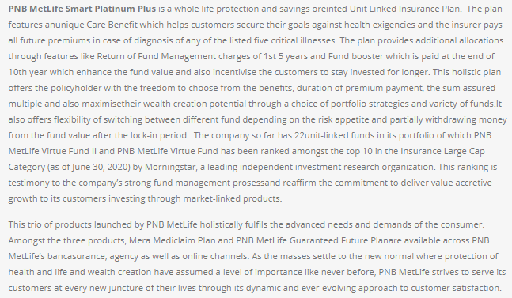

Publication : CXO Outlook | Edition : Online
Date : August 3,2020 | Headline: PNB MetLife broadens its product portfolio with three unique offerings for retail customers


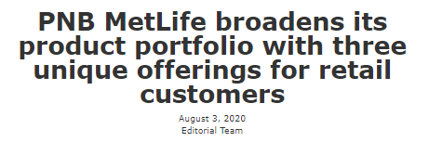

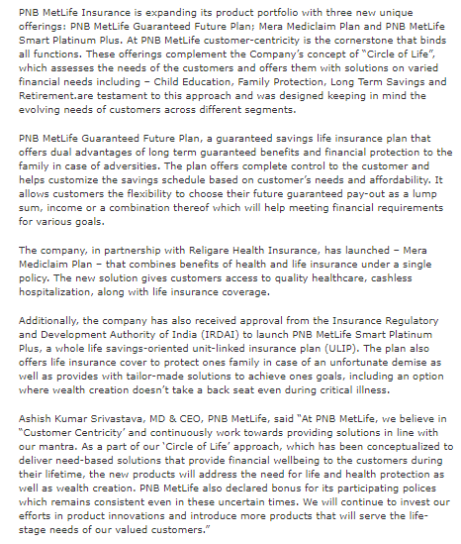



Publication : CXO Outlook | Edition : Online
Date : August 3,2020 | Headline: PNB MetLife broadens its product portfolio with three unique offerings for retail customers

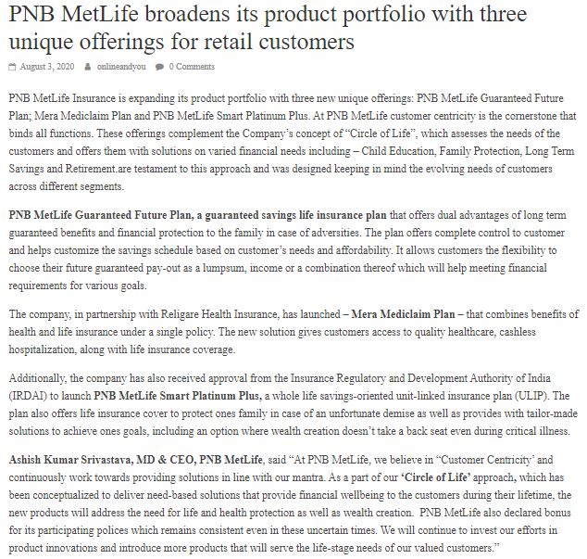

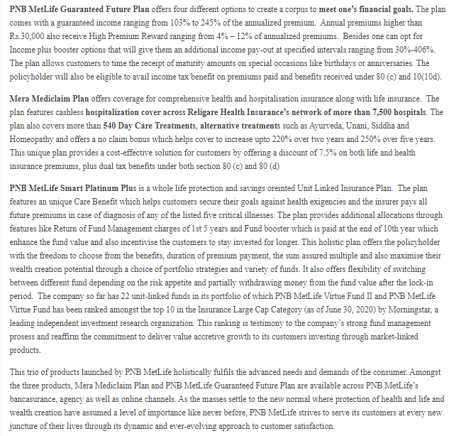

Publication : HR Katha | Edition : Online
Date : Jul 31,2020 | Headline: How PNB MetLife’s workforce is coping with the virtual model


