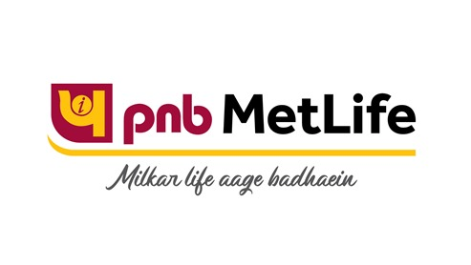

Coverage Report
On
PNB METLIFE
Updated on: October 2020

PRINT

Coverage compilation on "PNB MetLife India Insurance from October 01, 2020 To October 31, 2020"
No. | Publication/Portal | Headline | Date
1 | The Economic Times Wealth | Join Hands to Gain More | October 12, 2020
2 | The Hindu | Life insurance term plan premium | October 19, 2020

Publication : The Economic Times Wealth | Edition : All
Date : October 12, 2020 | Page: 2


Publication : The Economic Times Wealth | Edition : All
Date : October 12, 2020 | Page: 3
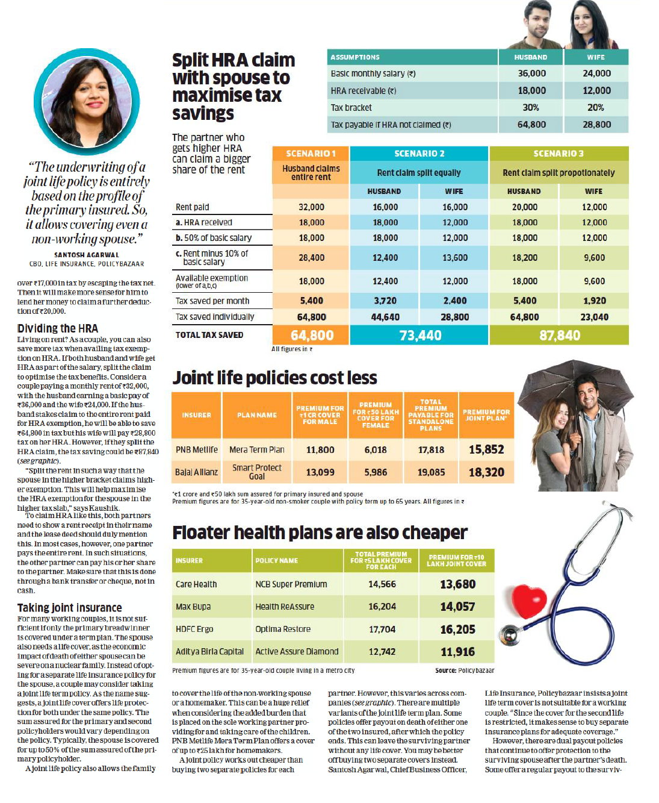

Publication : The Economic Times Wealth | Edition : All
Date : October 12, 2020 | Page: 4


Publication : The Hindu | Edition : Bangalore, Noida, Mumbai, Kochi, Hyderabad, Chennai
Date : October 19, 2020 | Page: 12
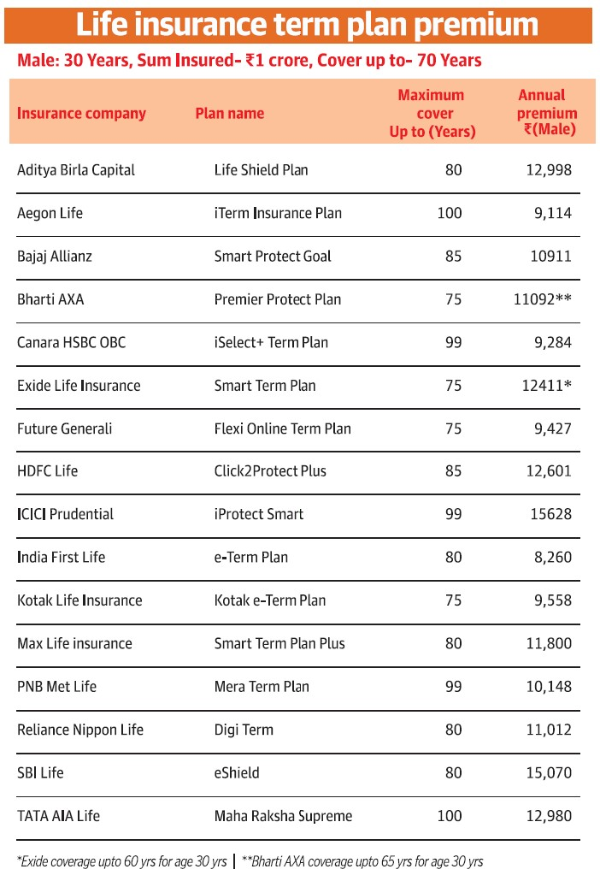

ONLINE

No. | Publication/Portal | Headline | Date
1 | The Economic Times Wealth | Money & relationships: 5 ways parents can pass on money related anxiety to their children | October 12, 2020

Publication : The Economic Times Wealth | Edition : Online
Date : October 12, 2020 | Headline: Money & relationships: 5 ways parents can pass on money related anxiety to their children





