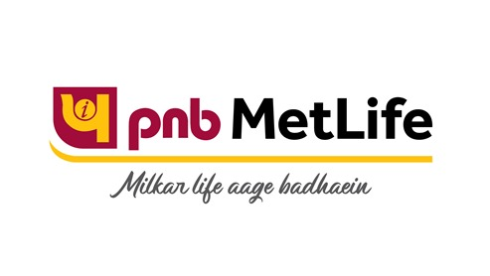

Coverage Report
On
PNB METLIFE
Updated on: September 2020

PRINT

No. | Publication/Portal | Headline | Date
1 | The Hindu | Life insurance term plan premium | September 07, 2020
2 | Business Standard | Insurance goes digital | September 21, 2020
3 | The Hans India | Theme: Consolidation of Insurance Companies | September 27, 2020
4 | The Hindu | Life insurance term plan premium | September 28, 2020

Publication : The Hindu | Edition : Bangalore, Noida, Mumbai, Kochi, Hyderabad, Chennai
Date : September 07, 2020 | Page: 13
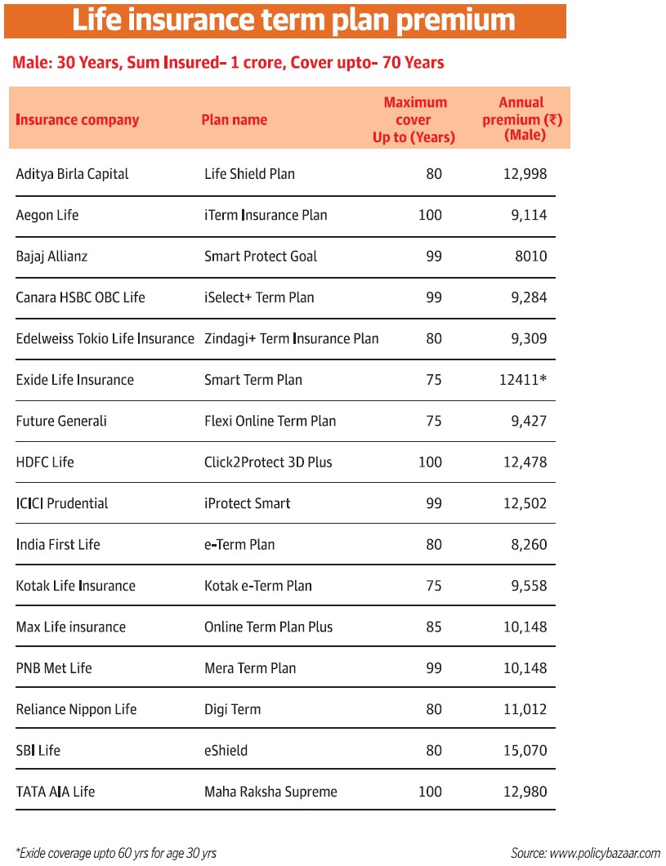

Publication : Business Standard | Edition : Ahmedabad, New Delhi, Mumbai, Chandigarh
Date : September 21, 2020 | Page: 14


Publication : The Hans India | Edition : Hyderabad, New Delhi
Date : September 27, 2020 | Page: 7
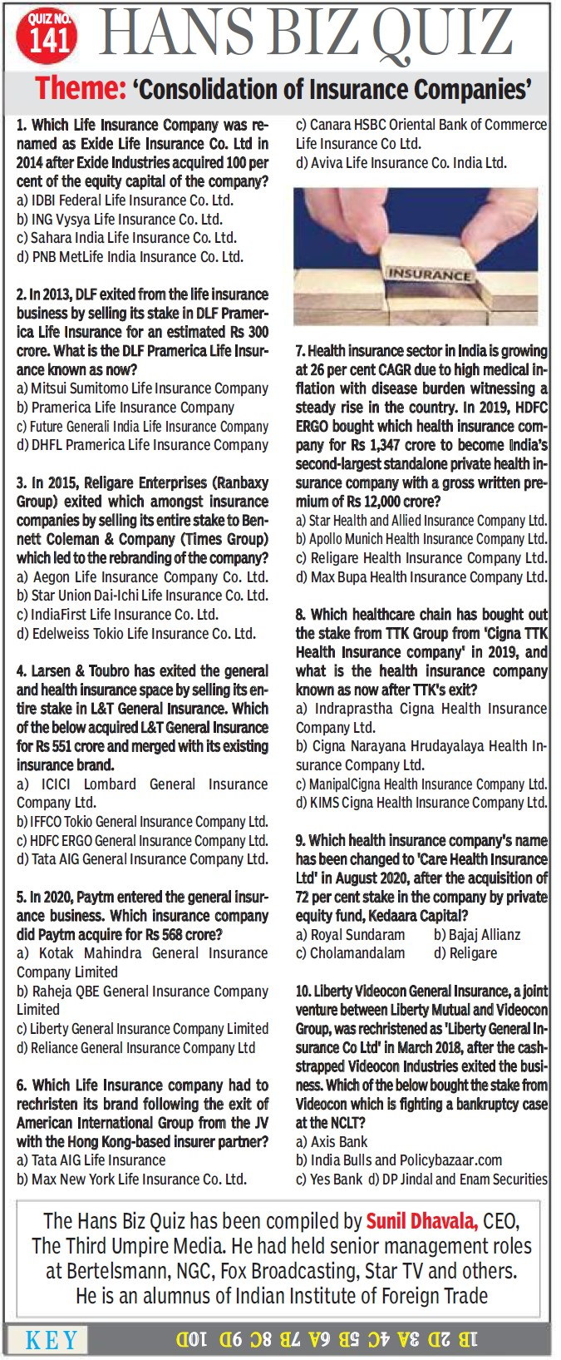

Publication : The Hindu | Edition : Bangalore, Noida, Mumbai, Kochi, Hyderabad, Chennai
Date : September 28, 2020 | Page: 12
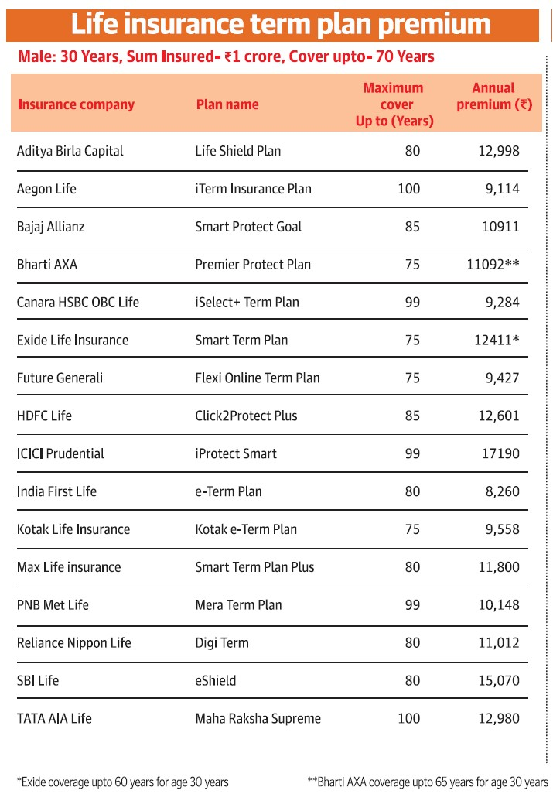

ONLINE

No. | Publication/Portal | Headline | Date
1 | CNBC TV18 | Buy Corona Kavach as an add-on with regular term plan for overall protection | September 14, 2020
2 | Business Standard | India Inc looks to raise more than Rs 50,000 crore from IPOs in FY21 | September 18, 2020
3 | Analytics Insight | INTELLIGENT VIRTUAL AGENTS ACCELERATE WORKFLOW AMONG CORPORATES | September 2, 2020
4 | The Free Press Journal | India Inc to raise more than Rs 50,000 crore from IPOs | September 17, 2020

Publication : CNBC TV18 | Edition : Online
Date : September 14,2020 | Headline: Buy Corona Kavach as an add-on with regular term plan for overall protection







Publication : Business Standard | Edition : Online
Date : September 18,2020 | Headline: India Inc looks to raise more than Rs 50,000 crore from IPOs in FY21


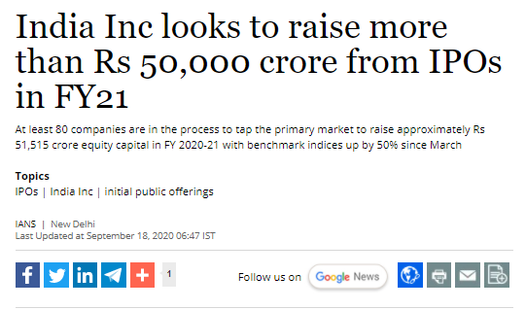





Publication : Analytics Insight | Edition : Online
Date : September 2,2020 | Headline: INTELLIGENT VIRTUAL AGENTS ACCELERATE WORKFLOW AMONG CORPORATES




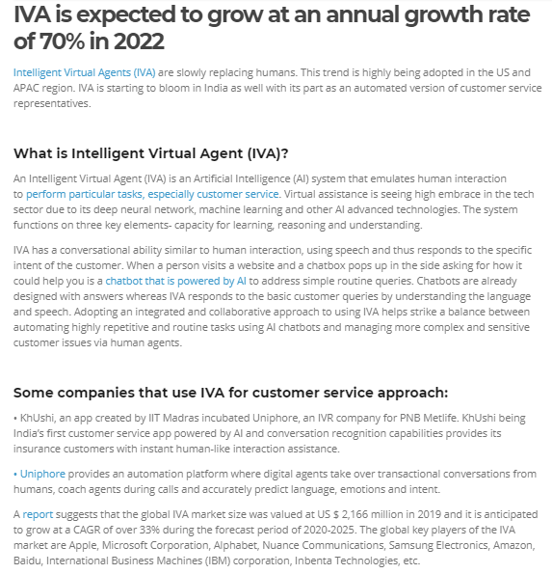

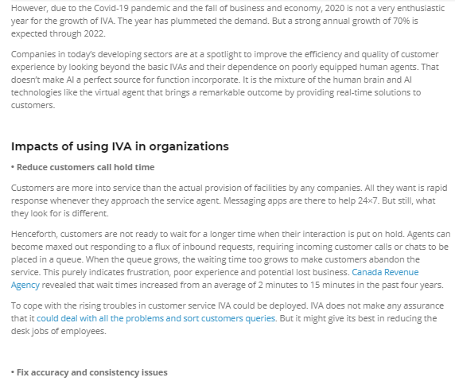

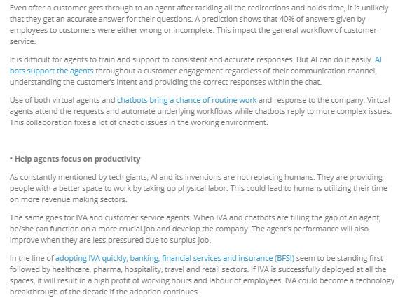

Publication : The Free Press Journal | Edition : Online
Date : September 17,2020 | Headline: India Inc to raise more than Rs 50,000 crore from IPOs

