

Coverage Report
On
PNB METLIFE
Updated on: December 2020

WIRES
No. | Publication/Portal | Headline | Date
1 | UNI | Mohit Bahuguna joins PNB MetLife to lead Group Business and Partnership Distribution | December 15, 2020

Publication : UNI | Edition : Online
Date : December 15,2020 | Headline: Mohit Bahuguna joins PNB MetLife to lead Group Business and Partnership Distribution


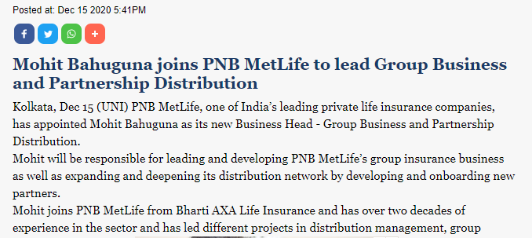

PRINT

No. | Publication/Portal | Headline | Date
1 | Free Press | ESAF Small Fin Bank hikes IPO size to Rs 998 cr | December 2, 2020
2 | The Hindu Business Line | Insurance premium tracker | December 13, 2020
3 | The Economic Times Wealth | 10 Financial Dilemmas | December 14, 2020
4 | Outlook Money | Best Practices In Claim Settlement | December 14, 2020
5 | Outlook Money | For A Resilient Ecosystem | December 14, 2020
6 | Ditta Dwani | PNB MetLife appoints Mohit Bahuguna as Business Head - Group Business and Partnership Distribution | December 16, 2020
7 | Amogha Vani | PNB MetLife appoints Mohit Bahuguna as Business Head - Group Business and Partnership Distribution | December 16, 2020
8 | Hosadigantha | PNB MetLife appoints Mohit Bahuguna as Business Head - Group Business and Partnership Distribution | December 16, 2020
9 | Jayakirana | PNB MetLife appoints Mohit Bahuguna as Business Head - Group Business and Partnership Distribution | December 16, 2020
10 | Karavali Ale | PNB MetLife appoints Mohit Bahuguna as Business Head - Group Business and Partnership Distribution | December 16, 2020
11 | Samyukta Karnataka | PNB MetLife appoints Mohit Bahuguna as Business Head - Group Business and Partnership Distribution | December 16, 2020
12 | Sanjevani | PNB MetLife appoints Mohit Bahuguna as Business Head - Group Business and Partnership Distribution | December 16, 2020
13 | Vijay Karnataka | PNB MetLife appoints Mohit Bahuguna as Business Head - Group Business and Partnership Distribution | December 16, 2020
14 | Echo Of India | Mohit Bahuguna joins PNB MetLife | December 19, 2020
15 | The Hindu Business Line | Insurance premium tracker | December 20, 2020
16 | The New Indian Express | Kalyan, ESAF to raise 2,750cr through IPO in new year | December 22, 2020
17 | The Hindu Business Line | Insurance premium tracker | December 27, 2020

Publication : Free Press | Edition : Bhopal, Indore, Mumbai
Date : December 2, 2020 | Page: 13


Publication : The Hindu Business Line | Edition : Mumbai
Date : December 13, 2020 | Page: 9

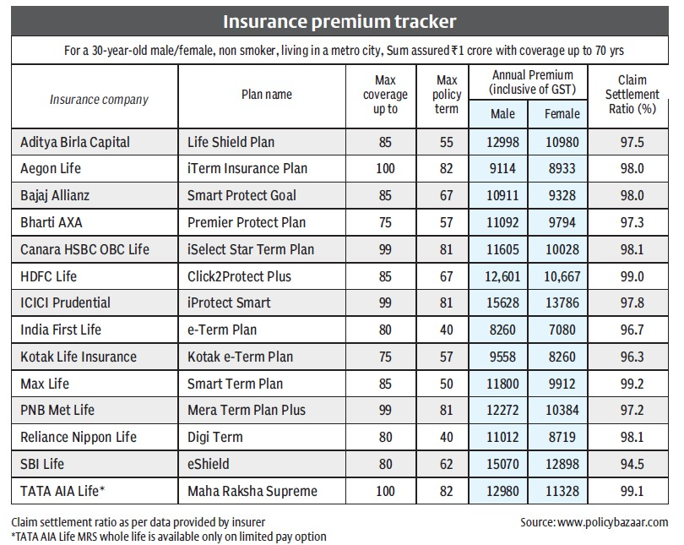

Publication : The Economic Times Wealth | Edition : All
Date : December 14, 2020 | Page: 10



Publication : Outlook Money | Edition : National
Date : December 14, 2020 | Page: 61



Publication : Outlook Money | Edition : National
Date : December 14, 2020 | Page: 61



Publication : Ditta Dwani | Edition : Mangalore
Date : December 16, 2020 | Page: 1



Publication : Amogha Vani | Edition : Mangalore
Date : December 16, 2020 | Page: 3



Publication : Hosadigantha | Edition : Mangalore
Date : December 16, 2020 | Page: 9



Publication : Jayakirana | Edition : Mangalore
Date : December 16, 2020 | Page: 3



Publication : Karavali Ale | Edition : Mangalore
Date : December 16, 2020 | Page: 4



Publication : Samyukta Karnataka | Edition : Mangalore
Date : December 16, 2020 | Page: 2



Publication : Sanjevani | Edition : Mangalore
Date : December 16, 2020 | Page: 4



Publication : Vijay Karnataka | Edition : Mangalore
Date : December 16, 2020 | Page: 10



Publication : Echo Of India | Edition : Mangalore
Date : December 19, 2020 | Page: 8



Publication : The Hindu Business Line | Edition : Mumbai
Date : December 20, 2020 | Page: 9

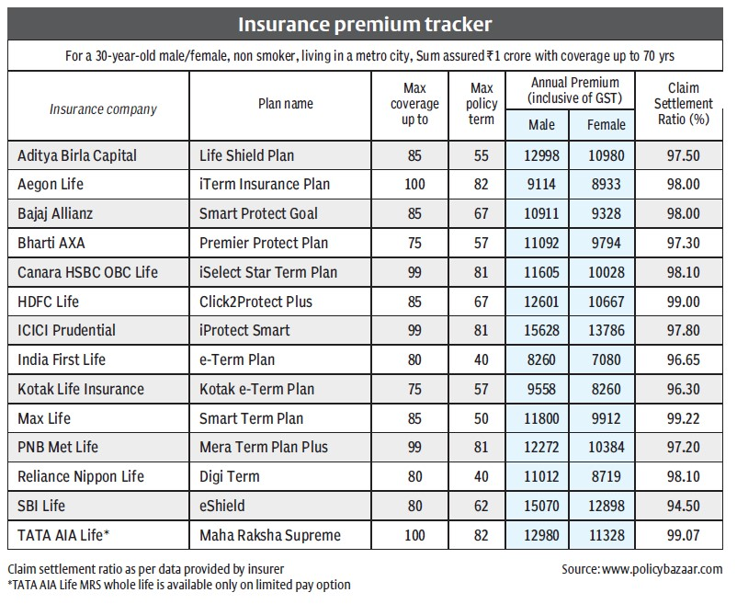

Publication : The New Indian Express | Edition : Kochi
Date : December 22, 2020 | Page: 12



Publication : The Hindu Business Line | Edition : Mumbai
Date : December 27, 2020 | Page: 9

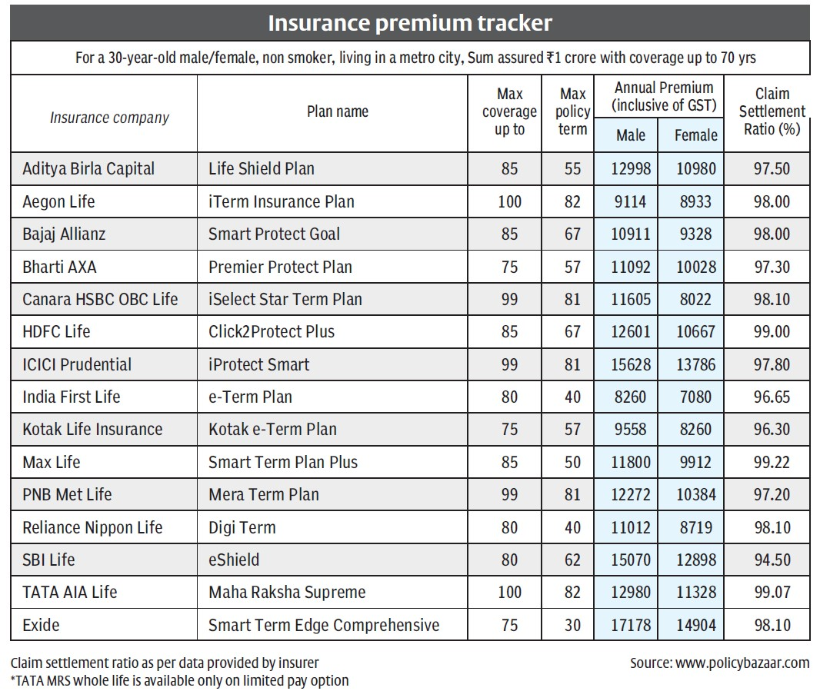

ONLINE

No. | Publication/Portal | Headline | Date
 | Business World | Why A Rich Customer Experience Is Critical For BFSI Firms | December 02, 2020
 | ET HR World.Com | PNB MetLife appoints Mohit Bahuguna as Business Head- Group Business and Partnership Distribution | December 15, 2020
 | City Air News | Mohit Bahuguna joins PNB MetLife to lead group business and partnership distribution | December 15, 2020
 | Hrnxt | Mohit Bahuguna appointed Business Head – Group Business and Partnership Distribution at PNB MetLife | December 15, 2020
 | Insurance Alertss | PNB MetLife appoints Mohit Bahuguna as Business Head- Group Business and Partnership Distribution | December 15, 2020
 | The News Strike | PNB MetLife appoints Mohit Bahuguna as Business Head- Group Business and Partnership Distribution | December 15, 2020
 | Ground News | PNB MetLife appoints Mohit Bahuguna as Business Head - Group Business and Partnership Distribution | December 17, 2020
 | Business World | Mohit Bahuguna Joins PNB MetLife to lead Group Business and Partnership Distribution | December 18, 2020

Publication : Business World | Edition : Online
Date : December 2, 2020 | Headline: Why A Rich Customer Experience Is Critical For BFSI Firms




Publication : ET HR World.Com | Edition : Online
Date : December 15,2020 | Headline: PNB MetLife appoints Mohit Bahuguna as Business Head- Group Business and Partnership Distribution




Publication : City Air News | Edition : Online
Date : December 15,2020 | Headline: Mohit Bahuguna joins PNB MetLife to lead group business and partnership distribution




Publication : Hrnxt | Edition : Online
Date : December 15,2020 | Headline: Mohit Bahuguna appointed Business Head – Group Business and Partnership Distribution at PNB MetLife




Publication : Insurance Alertss | Edition : Online
Date : December 15,2020 | Headline: PNB MetLife appoints Mohit Bahuguna as Business Head- Group Business and Partnership Distribution


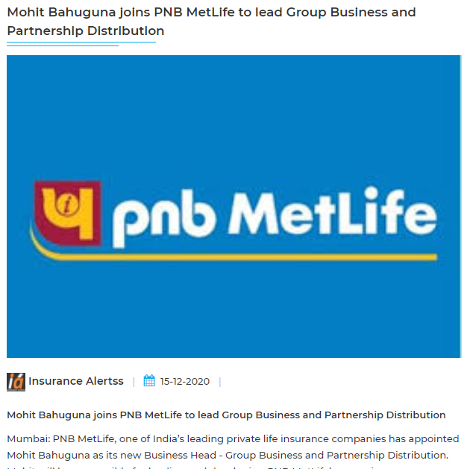

Publication : The News Strike | Edition : Online
Date : December 15,2020 | Headline: PNB MetLife appoints Mohit Bahuguna as Business Head- Group Business and Partnership Distribution


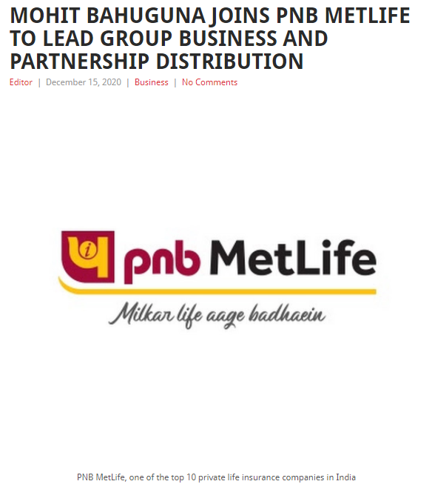
Publication : Ground News | Edition : Online
Date : December 17,2020 | Headline: PNB MetLife appoints Mohit Bahuguna as Business Head - Group Business and Partnership Distribution


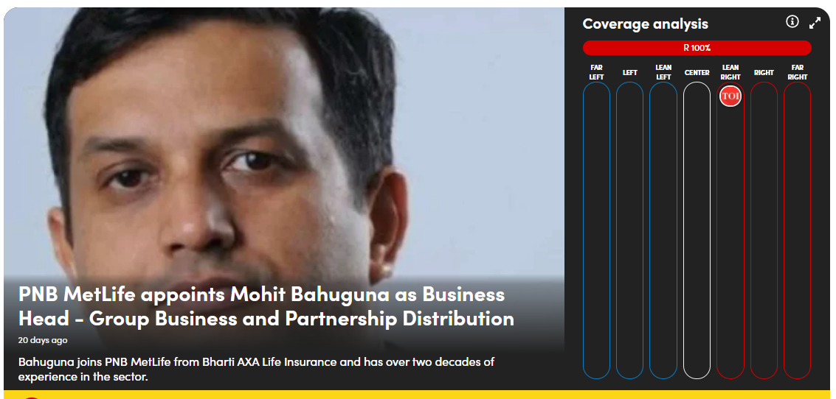

Publication : Business World | Edition : Online
Date : December 18,2020 | Headline: Mohit Bahuguna Joins PNB MetLife to lead Group Business and Partnership Distribution




