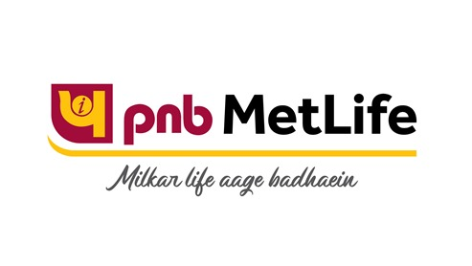

Coverage Report
On
PNB METLIFE
Updated on: November 2020

WIRES
No. | Publication/Portal | Headline | Date
1 | UNI | P.V. Sindhu & U. Vimal Kumar share fitness and badminton tips with youngsters | November 12, 2020
2 | UNI | Amidst rising Covid-19 cases, PNB MetLife urges adolescent girls and women under its CSR initiative ‘Damini’ to follow hygiene and safety protocols | November 19, 2020
3 | PTI | India Post Payments Bank ties up with PNB MetLife | November 24, 2020
4 | UNI | India Post Payments Bank introduces Pradhan Mantri Jeevan Jyoti Bima Yojana for Savings Bank Customers | November 24, 2020

Publication : UNI | Edition : Online
Date : November 12,2020 | Headline: P.V. Sindhu & U. Vimal Kumar share fitness and badminton tips with youngsters


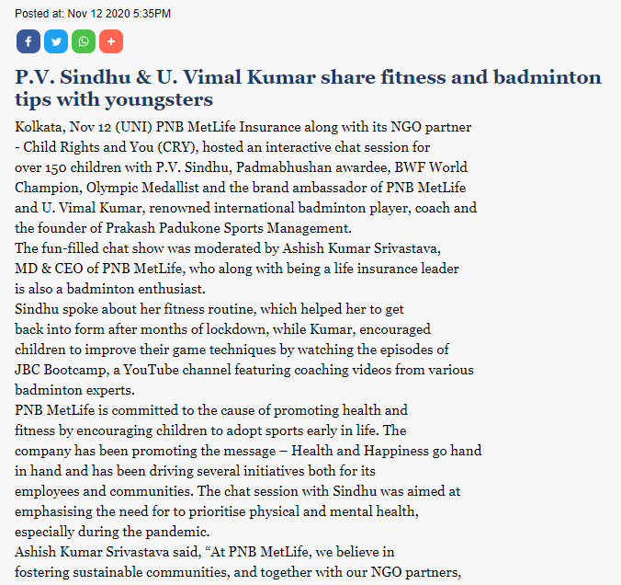

Publication : UNI | Edition : Online
Date : November 19,2020 | Headline: Amidst rising Covid-19 cases, PNB MetLife urges adolescent girls and women under its CSR initiative ‘Damini’ to follow hygiene and safety protocols

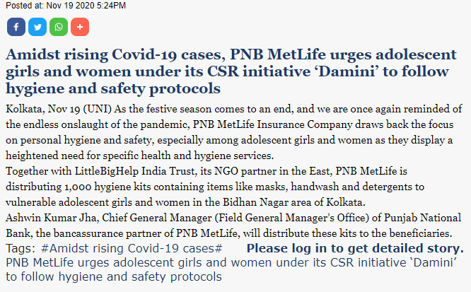

Publication : PTI | Edition : Online
Date : November 24,2020 | Headline: India Post Payments Bank ties up with PNB MetLife

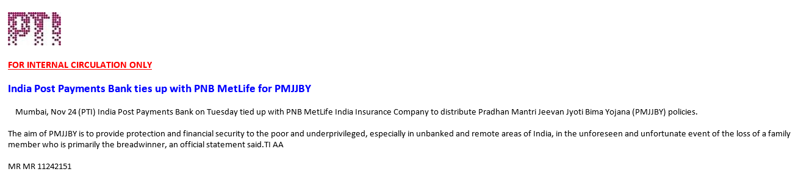

Publication : UNI | Edition : Online
Date : November 24,2020 | Headline: India Post Payments Bank introduces Pradhan Mantri Jeevan Jyoti Bima Yojana for Savings Bank Customers


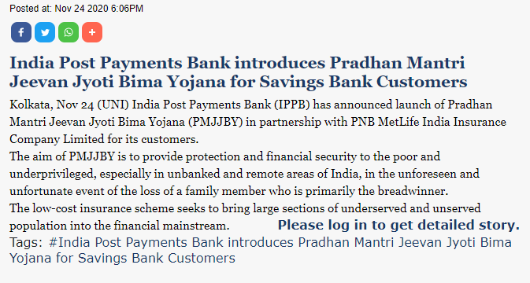

WIRES

Coverage compilation on "PNB MetLife India Insurance from November 01, 2020 To November 30, 2020"
No. | Publication/Portal | Headline | Date
1 | Satellite Samachar | P.V. Sindhu and U. Vimal Kumar share fitness and badminton tips with youngsters on Children’s Day organised by PNB MetLife | November 13, 2020
2 | Ahmedabad Express | P.V. Sindhu and U. Vimal Kumar share fitness and badminton tips with youngsters on Children's Day organised by PNB MetLife | November 14, 2020
3 | Gujarat Pranam | P.V. Sindhu and U. Vimal Kumar share fitness and badminton tips with youngsters on Children's Day organised by PNB MetLife | November 14, 2020
4 | Aaj | Badminton star PV Sindhu virtual chat | November 14, 2020
5 | Amogha Vani | Badminton star PV Sindhu virtual chat | November 14, 2020
6 | Lucknow News | P.V. Sindhu and U. Vimal Kumar share fitness and badminton tips with youngsters on Children's Day organised by PNB MetLife | November 14, 2020
7 | Sanjevani | Badminton star PV Sindhu virtual chat | November 15, 2020
8 | Ditta Dwani | Badminton star PV Sindhu virtual chat | November 15, 2020
9 | Uday Today | Badminton star PV Sindhu virtual chat | November 17, 2020
10 | Rashtriya Prastavana | Badminton star PV Sindhu virtual chat | November 17, 2020
11 | Suryakaal | Badminton star PV Sindhu virtual chat | November 19, 2020
12 | Suryakaal | P.V. Sindhu and U. Vimal Kumar share fitness and badminton tips with youngsters on Children’s Day organised by PNB MetLife | November 20, 2020
13 | Echo Of India | PNB MetLife focuses on hygiene & safety protocols | November 21, 2020
14 | Nishpaksh Divya Sandesh | IPPB launches PMJJBY in pact with PNB MetLife India | November 21, 2020
15 | The Hindu | Life insurance term plan premium | November 23, 2020
16 | Prabhat Daily | P.V. Sindhu and U. Vimal Kumar share fitness and badminton tips with youngsters on Children's Day organised by PNB MetLife | November 23, 2020
17 | The Financial Express | IPPB launches PMJJBY in pact with PNB MetLife India | November 25, 2020
18 | Divya Gujarati | India Post Payments Bank Introduces Pradhan Mantri Jeevan Jyoti Bima Yojana (PMJJBY) for Savings Bank Customers, Inks Agreement with PNB MetLife | November 25, 2020
19 | Gujarat Pranam | India Post Payments Bank Introduces Pradhan Mantri Jeevan Jyoti Bima Yojana (PMJJBY) for Savings Bank Customers, Inks Agreement with PNB MetLife | November 25, 2020
20 | Nirmal Gujarat | India Post Payments Bank Introduces Pradhan Mantri Jeevan Jyoti Bima Yojana (PMJJBY) for Savings Bank Customers, Inks Agreement with PNB MetLife | November 25, 2020
21 | Satellite Samachar | India Post Payments Bank Introduces Pradhan Mantri Jeevan Jyoti Bima Yojana (PMJJBY) for Savings Bank Customers, Inks Agreement with PNB MetLife | November 25, 2020
22 | Aaj | IPPB intorduces PMJJBY for Savings Bank Customers | November 25, 2020
23 | Ahmedabad Express | IPPB intorduces PMJJBY for Savings Bank Custom | November 25, 2020
24 | Amogha Vani | IPPB launches PMJJBY in pact with PNB MetLife India | November 25, 2020
25 | Divya Gujarati | IPPB intorduces PMJJBY for Savings Bank Customers | November 25, 2020
26 | Ditta Dwani | IPPB launches PMJJBY in pact with PNB MetLife India | November 25, 2020
27 | Every Day News | IPPB intorduces PMJJBY for Savings Bank Customers | November 25, 2020
28 | Gujarat Pranam | IPPB intorduces PMJJBY for Savings Bank Customers | November 25, 2020
29 | Jayakirana | IPPB launches PMJJBY in pact with PNB MetLife India | November 25, 2020
30 | Nirmal Gujarat | IPPB intorduces PMJJBY for Savings Bank Customers | November 25, 2020
31 | Morning India | India Post Payments Bank Introduces Pradhan MantriJ eevan Jyoti Bima Yojana | November 25, 2020
32 | Satellite Samachar | IPPB intorduces PMJJBY for Savings Bank Customers | November 25, 2020
33 | Prajavani | IPPB launches PMJJBY in pact with PNB MetLife India | November 25, 2020
34 | Samyukta Karnataka | IPPB launches PMJJBY in pact with PNB MetLife India | November 25, 2020
35 | Sanjevani | IPPB launches PMJJBY in pact with PNB MetLife India | November 25, 2020
36 | Herald Young Leader | IPPB launches PMJJBY in pact with PNB MetLife India | November 25, 2020
37 | Echo Of India | IPPB Introduces PMJJBY for Savings Bank Customers Inks agreement with PNB MetLife | November 26, 2020
38 | Maharashtra Times | India Post Payments Bank launches PM Jeevan Jyoti Bima Yojana for account holders | November 26, 2020
39 | Standard Herald | India Post Payments Bank Introduces Pradhan Mantri Jeevan Jyoti Bima Yojana (PMJJBY) for Savings Bank Customers, Inks Agreement with PNB MetLife | November 26, 2020
40 | Herald Young Leader | India Post Payments Bank Introduces Pradhan Mantri Jeevan Jyoti Bima Yojana (PMJJBY) for Savings Bank Customers, Inks Agreement with PNB MetLife | November 26, 2020
41 | Ahmedabad Express | India Post Payments Bank Introduces Pradhan Mantri Jeevan Jyoti Bima Yojana (PMJJBY) for Savings Bank Customers, Inks Agreement with PNB MetLife | November 26, 2020
42 | Hosadigantha | PMJJBY Introduced by Post Bank | November 26, 2020
43 | Rashtriya Prastavana | India Post Payments Bank launches PM Jeevan Jyoti Bima Yojana for account holders | November 26, 2020
44 | Simhadhwani | PMJJBY Introduced by Post Bank | November 26, 2020
45 | Dainik Navshakti | India Post Payments Bank launches PM Jeevan Jyoti Bima Yojana for account holders | November 27, 2020

PRINT

Publication : Satellite Samachar | Edition : Ahmedabad
Date : November 13, 2020 | Page: 2
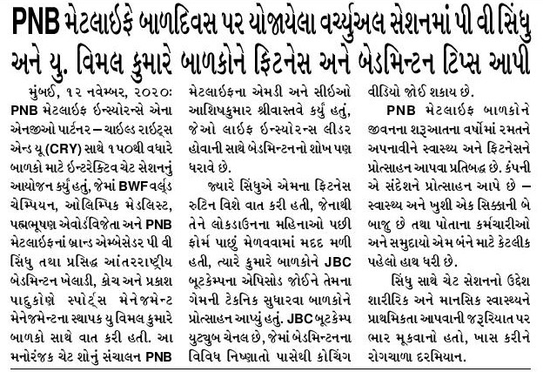

Publication : Ahmedabad Express | Edition : Ahmedabad
Date : November 14, 2020 | Page: 5
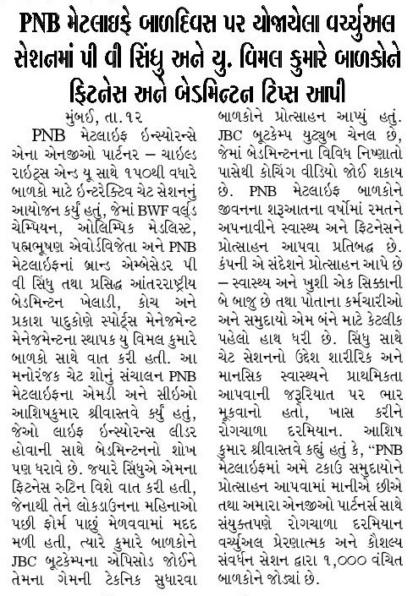

Publication : Gujarat Pranam | Edition : Ahmedabad
Date : November 14, 2020 | Page: 2
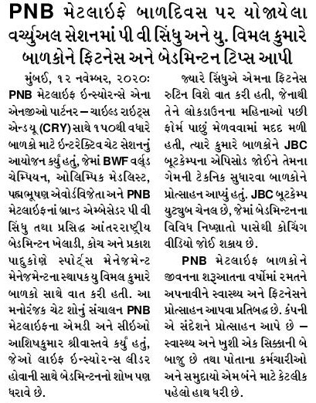

Publication : Aaj | Edition : Lucknow
Date : November 14, 2020 | Page: 9

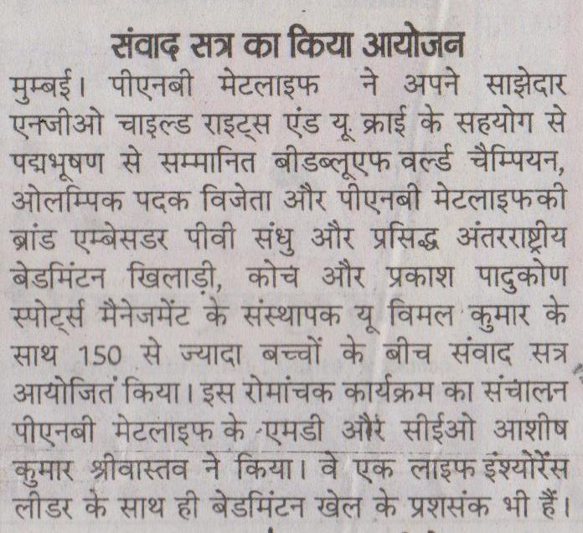

Publication : Amogha Vani | Edition : Mangalore
Date : November 14, 2020 | Page: 10

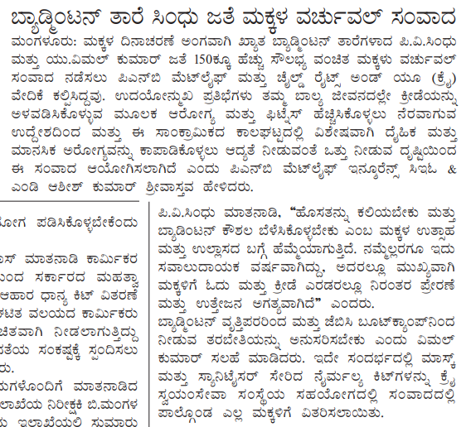

Publication : Lucknow News | Edition : Lucknow
Date : November 14, 2020 | Page: 4

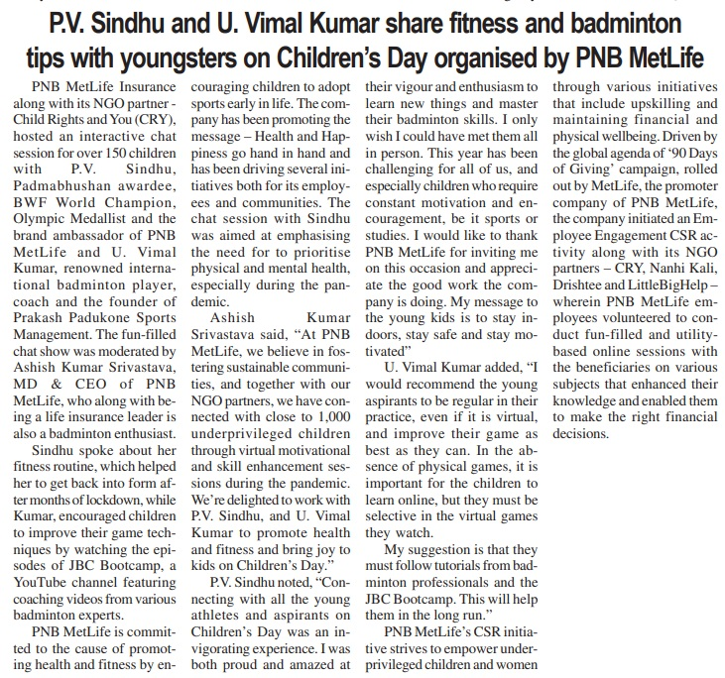

Publication : Sanjevani | Edition : Mangalore
Date : November 15, 2020 | Page: 4

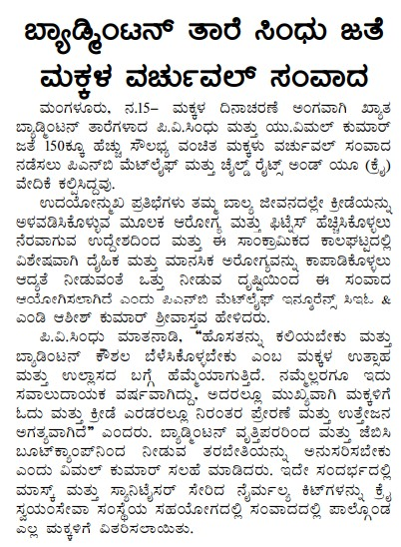

Publication : Ditta Dwani | Edition : Mangalore
Date : November 15, 2020 | Page: 8

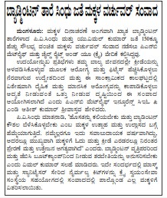

Publication : Uday Today | Edition : Jaipur
Date : November 17, 2020 | Page: 3

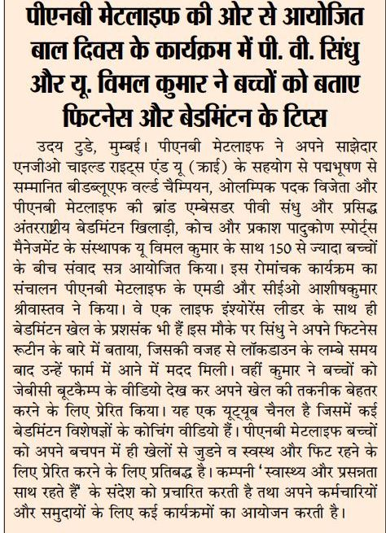

Publication : Rashtriya Prastavana | Edition : Lucknow
Date : November 17, 2020 | Page: 7

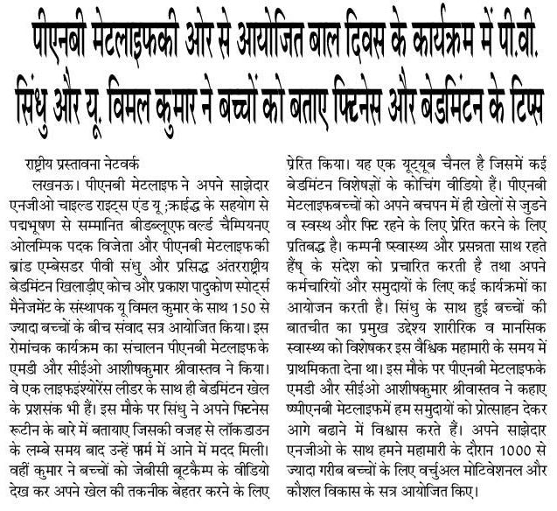

Publication : Suryakaal | Edition : Ahmedabad
Date : November 19, 2020 | Page: 2

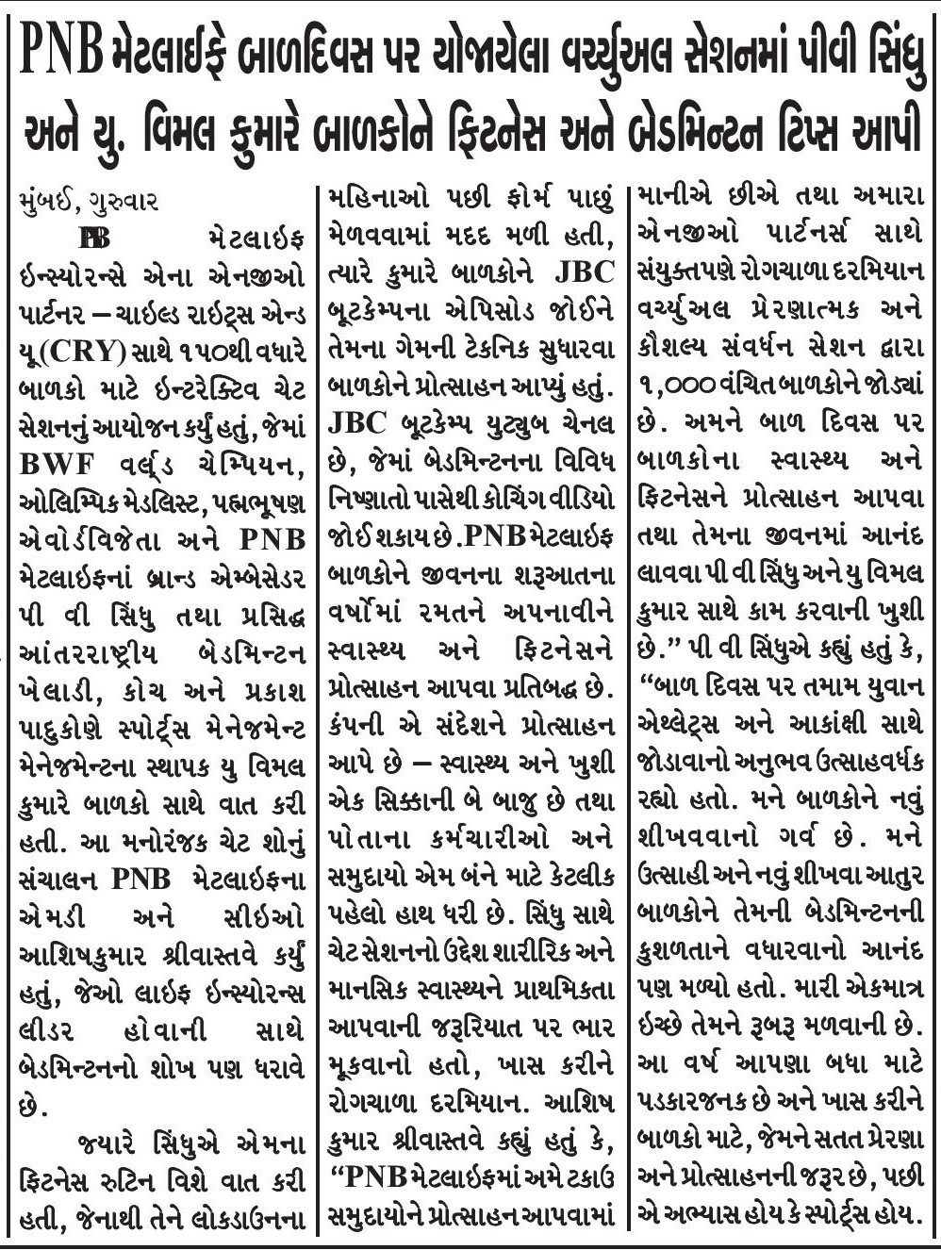
Publication : Suryakaal | Edition : Ahmedabad
Date : November 20, 2020 | Page: 2
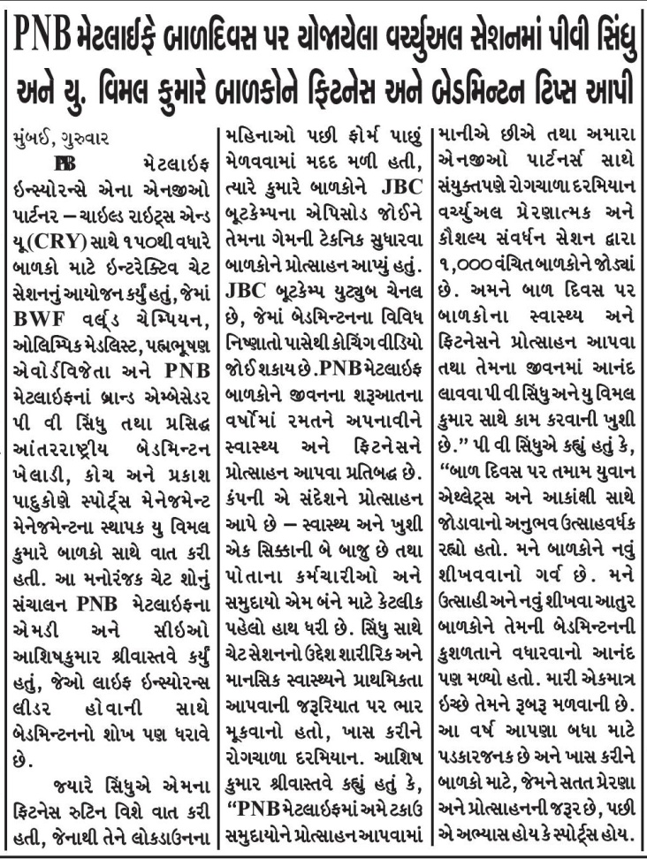

Publication : Echo Of India | Edition : Kolkata
Date : November 21, 2020 | Page: 8
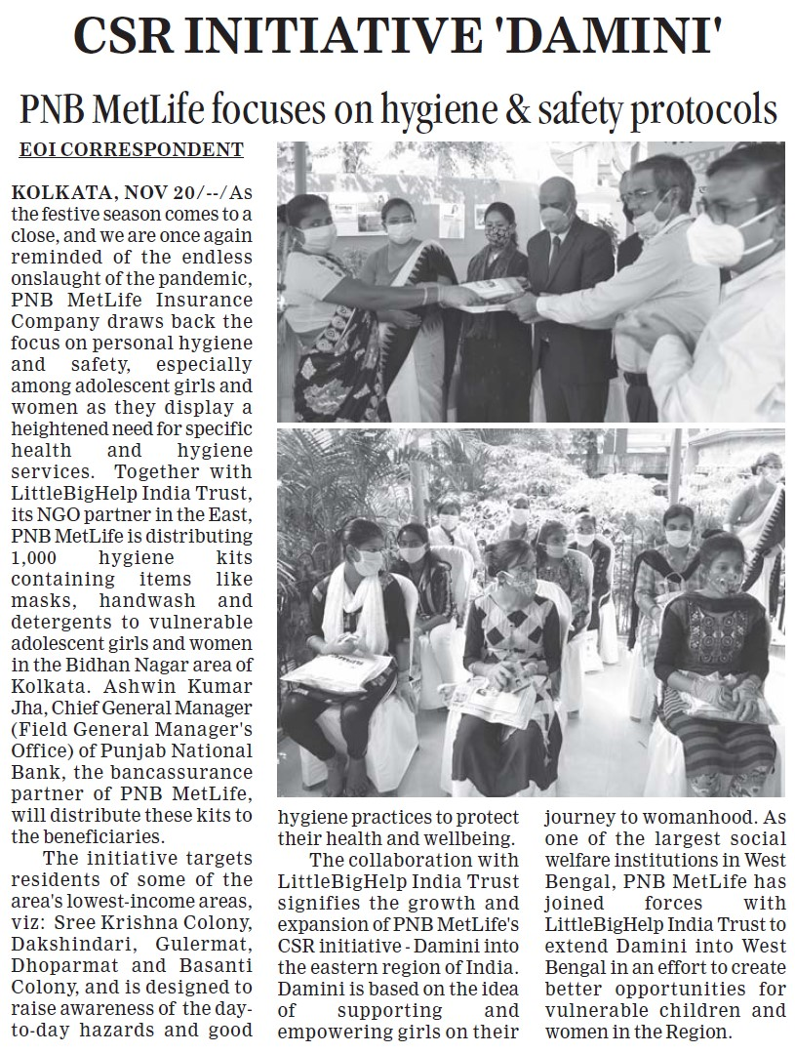

Publication : Nishpaksh Divya Sandesh | Edition : Chennai
Date : November 21, 2020 | Page: 11
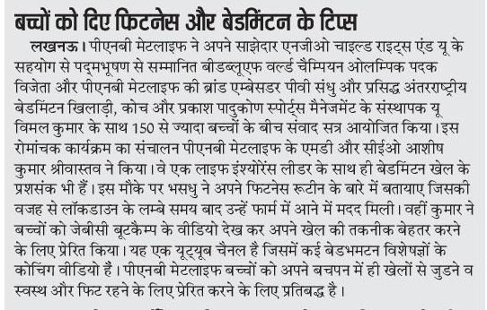

Publication : The Hindu | Edition : All
Date : November 23, 2020 | Page: 12
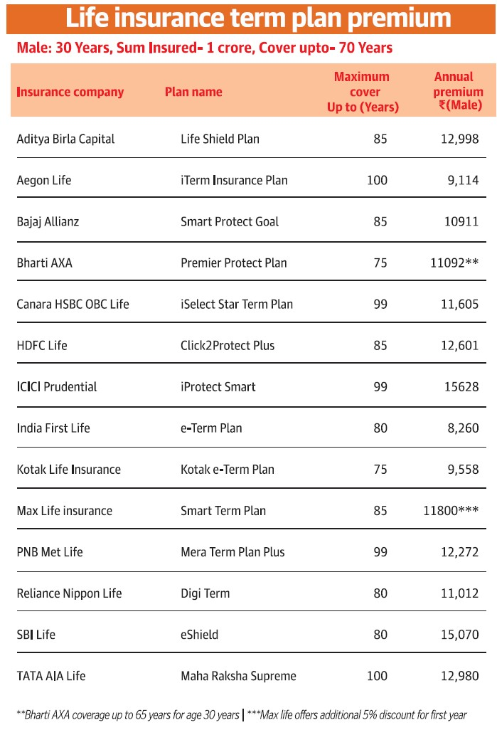

Publication : Prabhat Daily | Edition : Ahmedabad
Date : November 23, 2020 | Page: 3
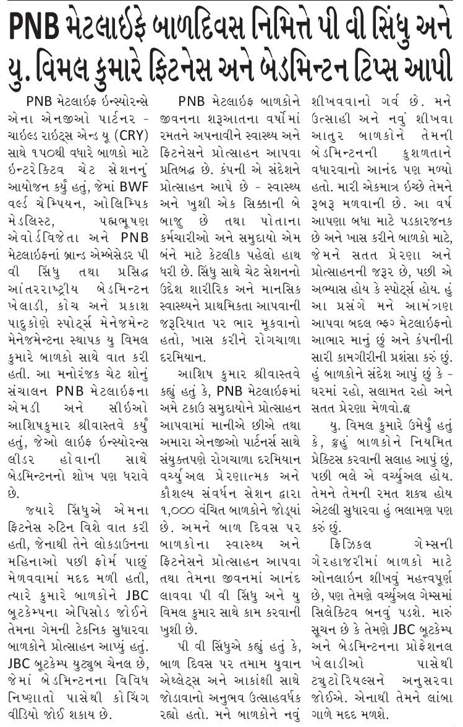

Publication : The Financial Express | Edition : All
Date : November 25, 2020 | Page: 10
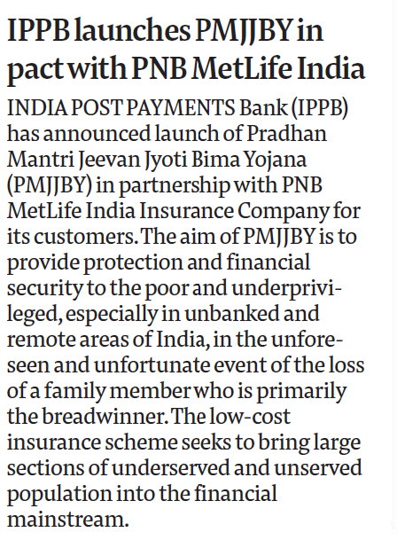

Publication : Divya Gujarati | Edition : Ahmedabad
Date : November 25, 2020 | Page: 3
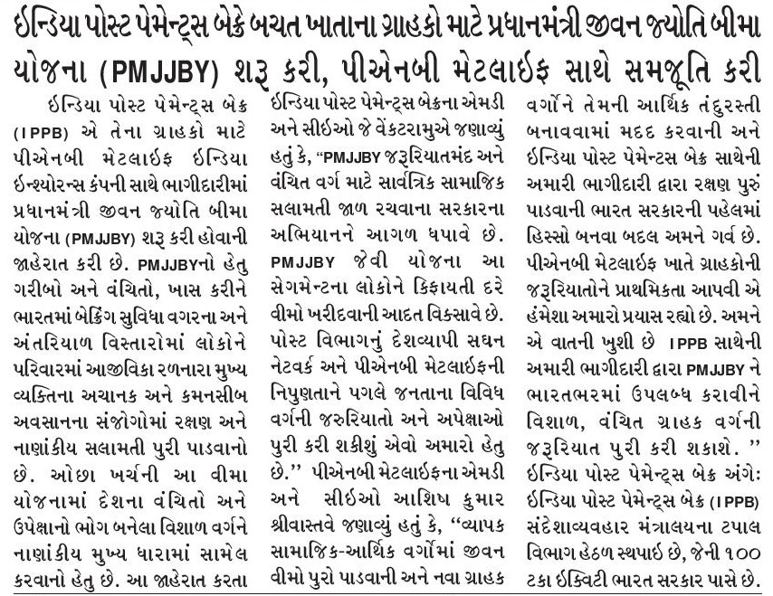

Publication : Gujarat Pranam | Edition : Ahmedabad
Date : November 25, 2020 | Page: 2
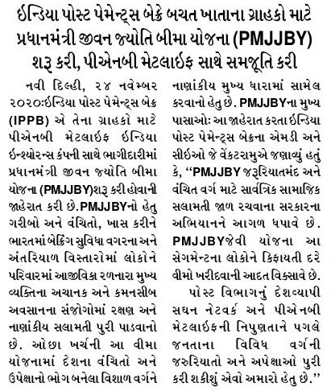

Publication : Nirmal Gujarat | Edition : Ahmedabad
Date : November 25, 2020 | Page: 3
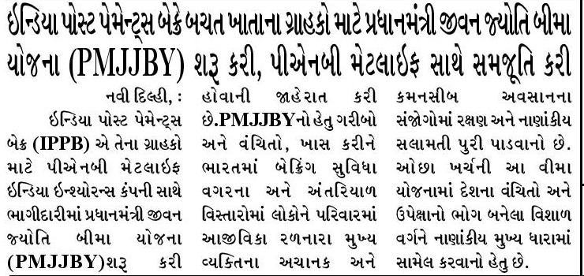

Publication : Satellite Samachar | Edition : Ahmedabad
Date : November 25, 2020 | Page: 2
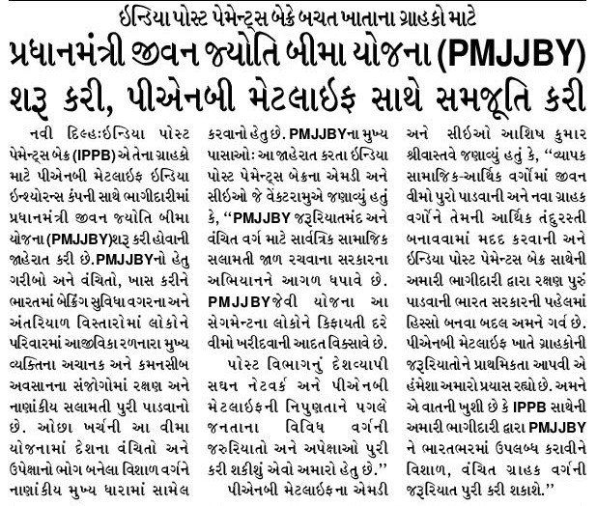

Publication : Aaj | Edition : Lucknow
Date : November 25, 2020 | Page: 5
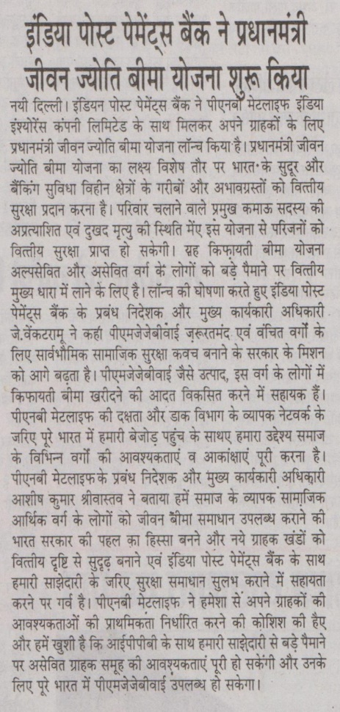

Publication : Ahmedabad Express | Edition : Ahmedabad
Date : November 25, 2020 | Page: 2
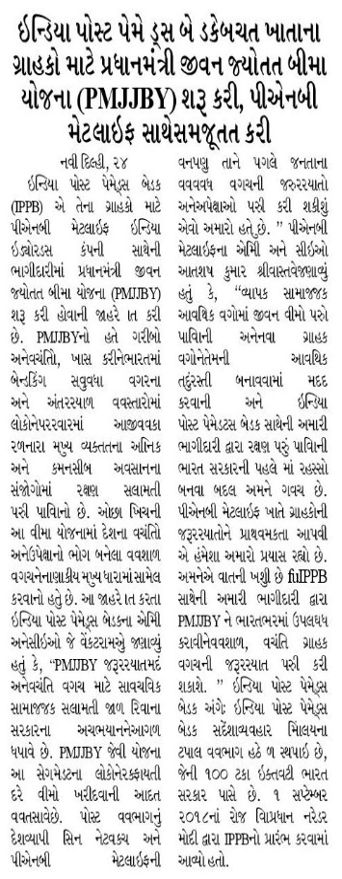

Publication : Amogha Vani | Edition : Mangalore
Date : November 25, 2020 | Page: 3
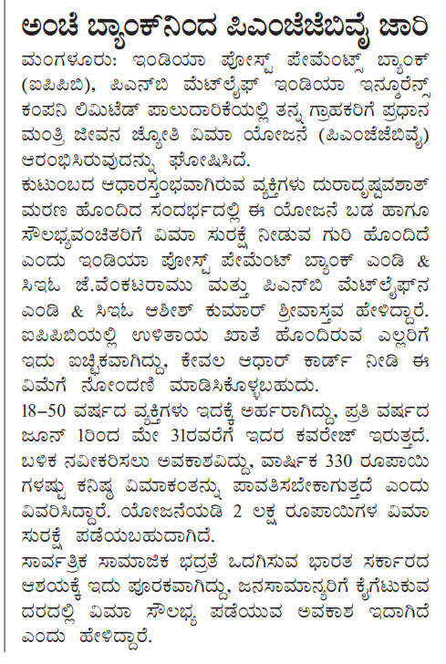

Publication : Divya Gujarati | Edition : Ahmedabad
Date : November 25, 2020 | Page: 3
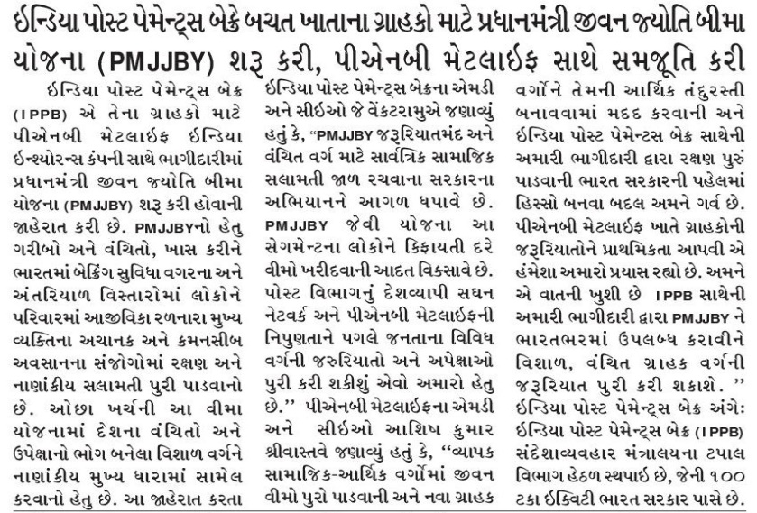

Publication : Ditta Dwani | Edition : Mangalore
Date : November 25, 2020 | Page: 1
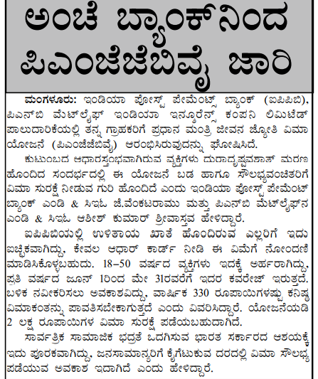

Publication : Every Day News | Edition : Lucknow
Date : November 25, 2020 | Page: 15
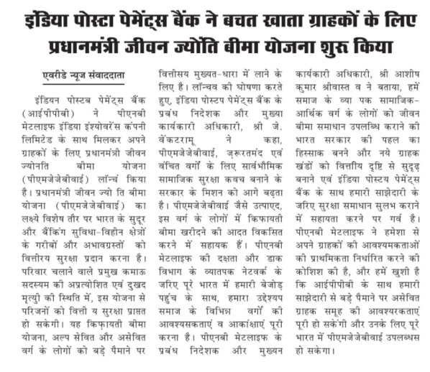

Publication : Gujarat Pranam | Edition : Ahmedabad
Date : November 25, 2020 | Page: 4

Publication : Jayakirana | Edition : Mangalore
Date : November 25, 2020 | Page: 2
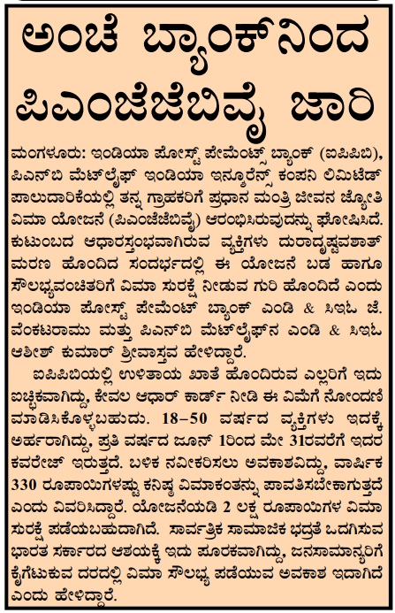

Publication : Nirmal Gujarat | Edition : Ahmedabad
Date : November 25, 2020 | Page: 6

Publication : Morning India | Edition : Kolkata
Date : November 25, 2020 | Page: 3
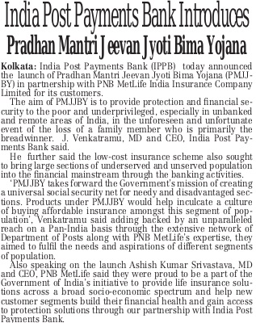

Publication : Satellite Samachar | Edition : Ahmedabad
Date : November 25, 2020 | Page: 6

Publication : Prajavani | Edition : Mangalore
Date : November 25, 2020 | Page: 3
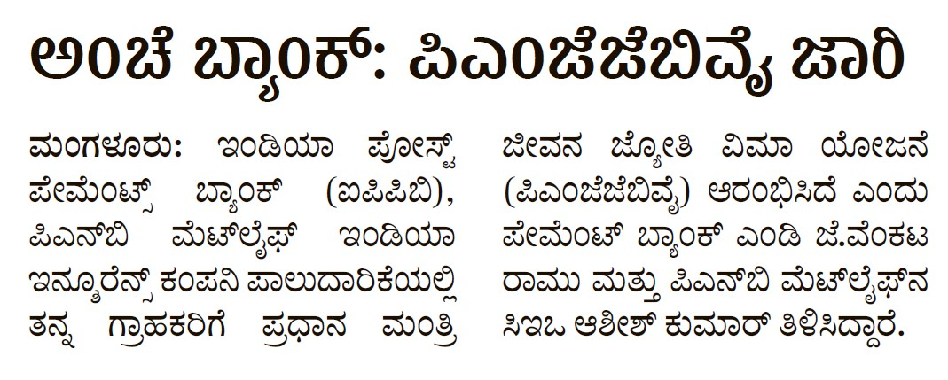

Publication : Samyukta Karnataka | Edition : Mangalore
Date : November 25, 2020 | Page: 8
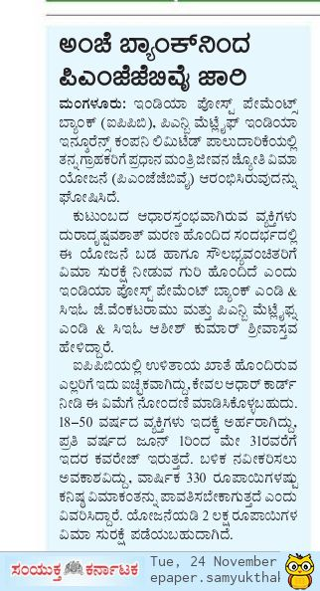

Publication : Sanjevani | Edition : Mangalore
Date : November 25, 2020 | Page: 4
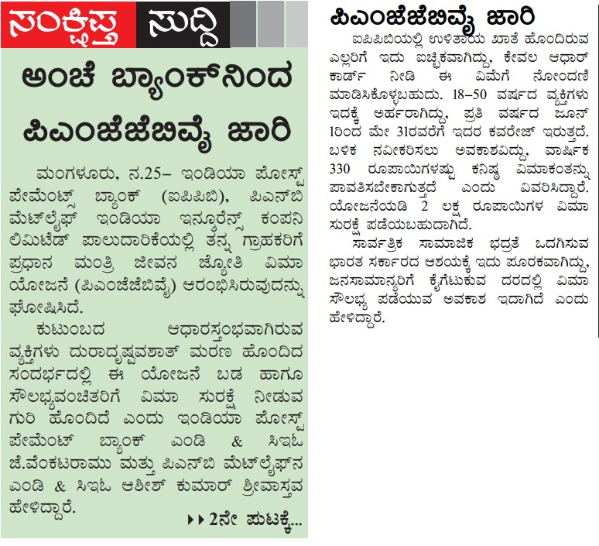

Publication : Herald Young Leader | Edition : Ahmedabad
Date : November 25, 2020 | Page: 5
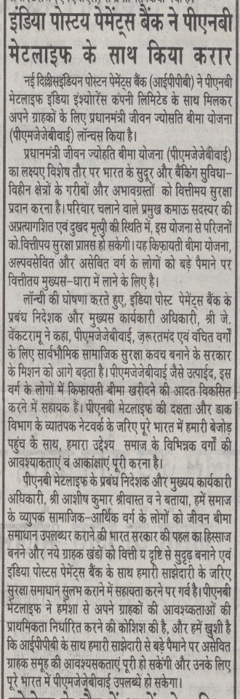

Publication : Echo Of India | Edition : Kolkata
Date : November 26, 2020 | Page: 8
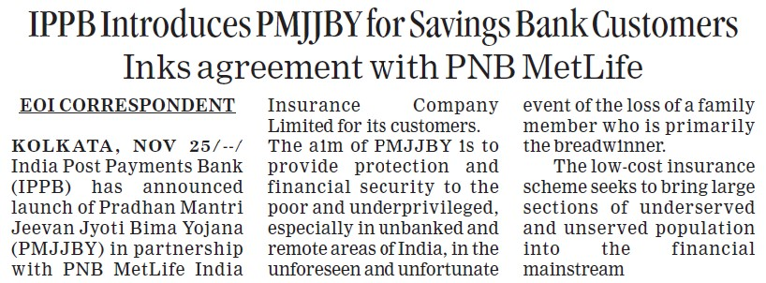

Publication : Maharashtra Times | Edition : Mumbai
Date : November 26, 2020 | Page: 8

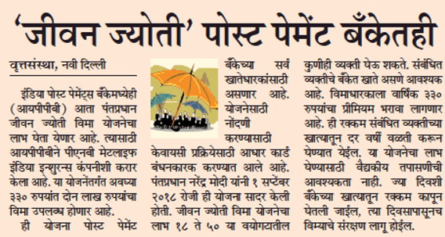

Publication : Standard Herald | Edition : Ahmedabad
Date : November 26, 2020 | Page: 7
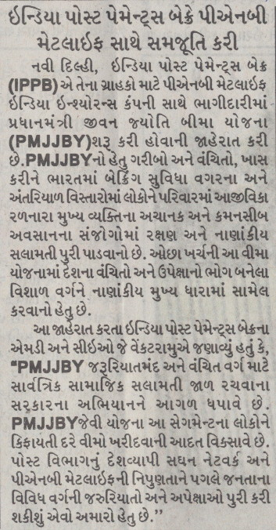

Publication : Herald Young Leader | Edition : Ahmedabad
Date : November 26, 2020 | Page: 7
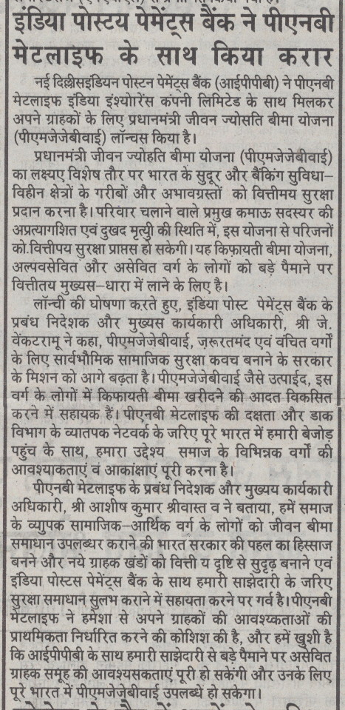

Publication : Ahmedabad Express | Edition : Ahmedabad
Date : November 26, 2020 | Page: 5
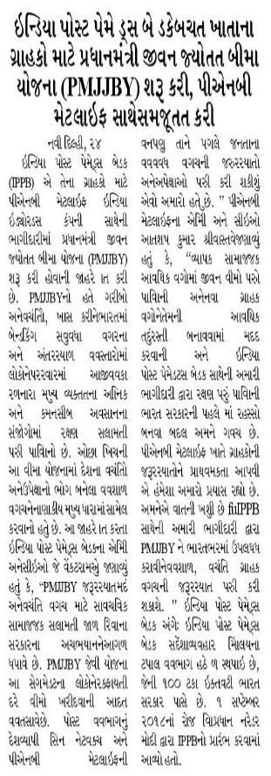

Publication : Hosadigantha | Edition : Mangalore
Date : November 26, 2020 | Page: 9
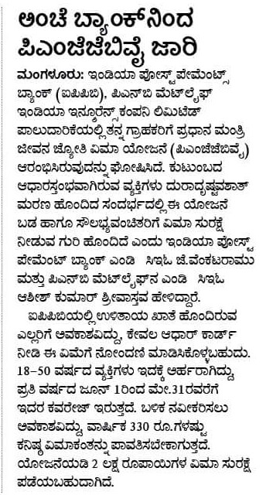

Publication : Rashtriya Prastavana | Edition : Lucknow
Date : November 26, 2020 | Page: 3
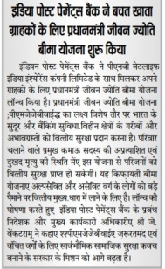

Publication : Simhadhwani | Edition : Mangalore
Date : November 26, 2020 | Page: 2
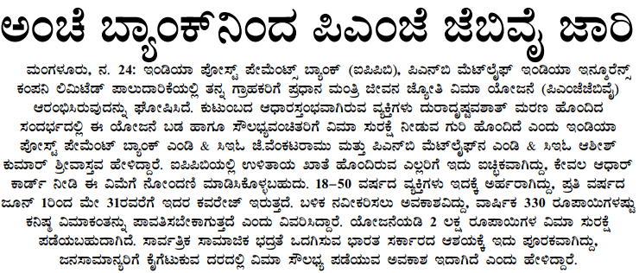

Publication : Dainik Navshakti | Edition : Mumbai
Date : November 27, 2020 | Page: 8
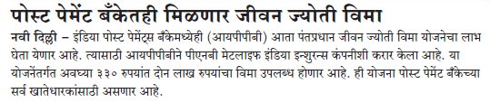

ONLINE

No. | Publication/Portal | Headline | Date
- 1 | Sportz Front | Sindhu, Vimal Kumar share fitness and badminton tips with youngsters | November 12, 2020
- 2 | Sports India Show | P.V. Sindhu, U. Vimal Kumar discuss badminton tips with youngsters via interactive chat session | November 12, 2020
- 3 | Babushahi | Sindhu and Vimal share fitness and badminton tips with youngsters on Children’s Day organised by PNB MetLife | November 12, 2020
- 41 | Arya TV | पीएनबी मेटलाइफ की ओर से आयोजित हुआ बाल दिवस कार्यक्रम | November 12, 2020
- 4 | The CSR Journal | Children’s Day 2020 – PV Sindhu and U. Vimal Kumar share badminton tips with youngsters | November 13, 2020
- 5 | The News Strike | P.V. SINDHU AND U. VIMAL KUMAR SHARE FITNESS AND BADMINTON TIPS WITH YOUNGSTERS ON CHILDREN’S DAY ORGANIZED BY PNB METLIFE | November 13, 2020
- 6 | Patrika Jagat | पीएनबी मेटलाइफ की ओर से आयोजित बाल दिवस के कार्यक्रम में पी. वी. सिंधु और यू. विमल कुमार ने बच्चों को बताए फिटनेस और बेडमिंटन के टिप्स | November 12, 2020
- 7 | Patrika Express | पीएनबी मेटलाइफ की ओर से आयोजित बाल दिवस के कार्यक्रम में पी. वी. सिंधु और यू. विमल कुमार ने बच्चों को बताए फिटनेस और बेडमिंटन के टिप्स | November 13, 2020
- 9 | Samnaa Activist | लाॅकडाउन के लम्बे समय बाद फिटनेस रूटीन से हुई फार्म वापसी : पीवी सिंधु | November 13, 2020
- 10 | Western Times | પી વી સધુઅનેય.ુવમલ ક ુ મારેબાળકાેનેફટનેસ અને બેડમન ટસ અાપી | November 13, 2020
- 11 | Efa News | Childrens Day 2020: P.V Sindhu and U. Vimal Kumar share badminton tips with youngsters | November 13, 2020
- 12 | The CSR Journal | PNB MetLife distributes hygiene kits under its CSR initiative Damini | November 19, 2020
- 13 | Sangbad Ekalavya | PNB MetLife urges adolescent girls and women under its CSR initiative ‘Damini’ to follow hygiene and safety protocols | November 20, 2020
- 14 | CSR Times | PNB MetLife in collaboration with its partner NGO-LittleBigHelp India Trust distributed hygiene kits amidst rising Covid-19 cases | November 20, 2020
- 15 | Adgully | Searches for insurance products up by 30% in the last 6 months: Nipun Kaushal | November 23, 2020
- 16 | Mint | India Post Payments Bank launches Pradhan Mantri Jeevan Jyoti Bima Yojana | November 24, 2020
- 17 | The Financial Express (Hindi) | India Post Payments Bank introduced PMJJBY for savings bank customers with PNB MetLife | November 24, 2020
- 18 | ET BFSI.com | IPPB ties-up with PNB MetLife to extend PMJJBY insurance | November 24, 2020
- 19 | Timesnownews.com | India Post Payments Bank introduces Pradhan Mantri Jeevan Jyoti Bima Yojana for savings bank customers | November 24, 2020
- 20 | The Banking & Finance Post | India Post Payments Bank partners PNB MetLife to launch Pradhan Mantri Jeevan Jyoti Bima Yojana | November 24, 2020
- 21 | Asia Insurance Review | India Insurer donates hygiene kits to low income communities | November 24, 2020
- 22 | India Infoline | India Post Payments Bank introduces Pradhan Mantri Jeevan Jyoti Bima Yojana PMJJBY for customers, inks agreement with PNB MetLife | November 24, 2020
- 23 | DNA | India Post Payments Bank launches Pradhan Mantri Jeevan Jyoti Bima Yojana for account holders | November 25, 2020
- 24 | The News Strike | India Post Payments Bank introduces Pradhan Mantri Jeevan Jyoti Bima Yojana: PMJJBY | November 24, 2020
- 25 | Odisha Expo | India Post Payments Bank launches Pradhan Mantri Jeevan Jyoti Bima Yojana for customers | November 24, 2020
- 26 | Catch News | India Post Payments Bank to provide insurance of Rs 2 lakh for Rs 330. This is how you can avail | November 24, 2020
- 29 | World News | India Post Payments Bank launches Pradhan Mantri Jeevan Jyoti Bima Yojana for customers | November 24, 2020
- 27 | Good Returns (Kannada) | IPPB launches Pradhan Mantri Jeevan Jyoti Bima Yojana eligibility features other details | November 25, 2020
- 28 | Just News Day | India Post Payments Bank launches Pradhan Mantri Jeevan Jyoti Bima Yojana for customers | November 25, 2020
- 30 | ABP Live.com | Post Payments Bank launches Pradhan Mantri Jeevan Jyoti Bima Yojana | November 25, 2020
- 32 | Affairs Cloud | IPPB partnered with PNB MetLife India to launch Pradhan Mantri Jeevan Jyoti Bima Yojana | November 25, 2020
- 33 | Informal Newz | India Post Payments Bank to provide insurance of 2 lakhs for 330 rupees: Know who can get benefit of this | November 25, 2020
- 34 | Byscoop | India Post Payments Bank launches PMJJBY | November 25, 2020
- 35 | Business News India | India Post Payments Bank inks agreement with PNB MetLife | November 25, 2020
- 36 | Times Bhaskar | India Post Payments Bank Introduces Pradhan Mantri Jeevan Jyoti Bima Yojana (PMJJBY) for Savings Bank Customers, Inks Agreement with PNB MetLife | November 25, 2020
- 37 | Gujarat Mirror | India Post Payments Bank introduces Pradhan Mantri Jeevan Jyoti Bima Yojana | November 25, 2020
- 38 | Asianet News | India Post Payments Bank introduces PMJJBY for Saving Bank Customers with MetLife | November 25, 2020
- 39 | Fact Report | Indian Post Payments Bank partners with PNB MetLife | November 25, 2020
- 31 | Prabhat Khabar | Post Payments Bank launches PMJJBY | November 26, 2020
- 40 | Live Bharat | आईपीपीबी ने बचत खाता ग्राहकों के लिए पीएमजेजेबीवाई शुरू किया | November 26, 2020

Publication : Sportz Front | Edition : Online
Date : November 12,2020 | Headline: Sindhu, Vimal Kumar share fitness and badminton tips with youngsters


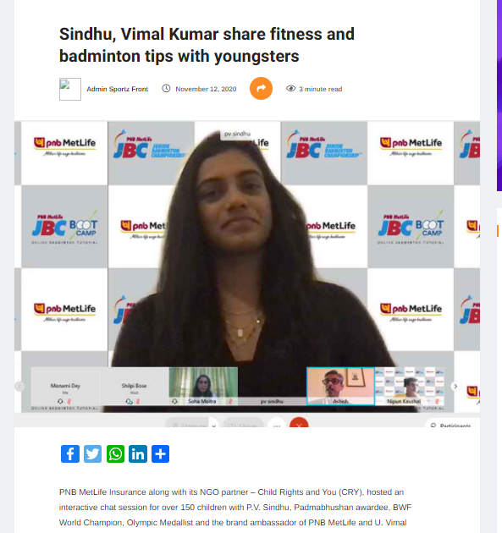

Publication : Sports India Show | Edition : Online
Date : November 12,2020 | Headline: P.V. Sindhu, U. Vimal Kumar discuss badminton tips with youngsters via interactive chat session


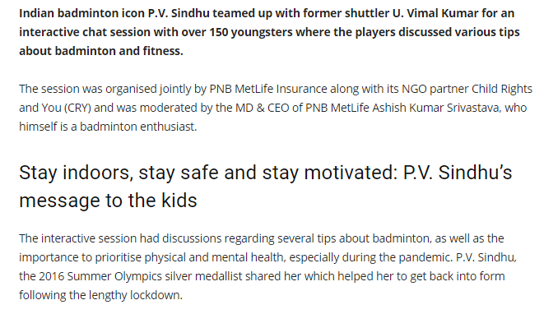

Publication : Babushahi | Edition : Online
Date : November 12,2020 | Headline: Sindhu and Vimal share fitness and badminton tips with youngsters on Children’s Day organised by PNB MetLife


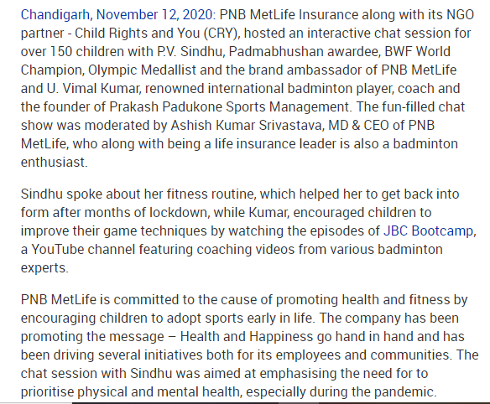

Publication : Babushahi | Edition : Online
Date : November 12,2020 | Headline: पीएनबी मेटलाइफ की ओर से आयोजित हुआ बाल दिवस कार्यक्रम


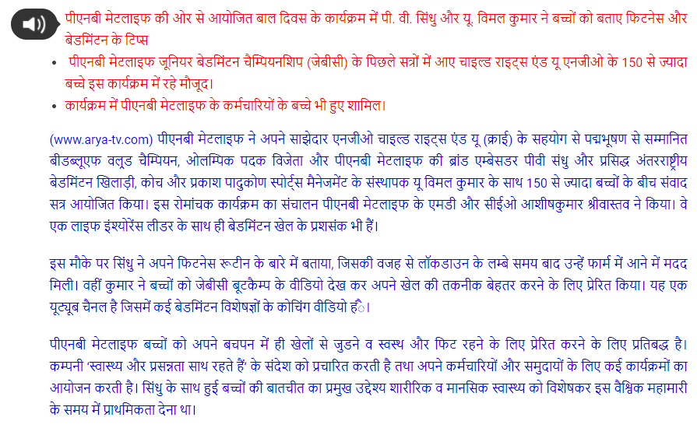

Publication : The CSR Journal | Edition : Online
Date : November 13,2020 | Headline: Children’s Day 2020 – PV Sindhu and U. Vimal Kumar share badminton tips with youngsters




Publication : The News Strike | Edition : Online
Date : November 13,2020 | Headline: P.V. SINDHU AND U. VIMAL KUMAR SHARE FITNESS AND BADMINTON TIPS WITH YOUNGSTERS ON CHILDREN’S DAY ORGANIZED BY PNB METLIFE




Publication : Patrika Jagat | Edition : Online
Date : November 12,2020 | Headline: पीएनबी मेटलाइफ की ओर से आयोजित बाल दिवस के कार्यक्रम में पी. वी. सिंधु और यू. विमल कुमार ने बच्चों को बताए फिटनेस और बेडमिंटन के टिप्स


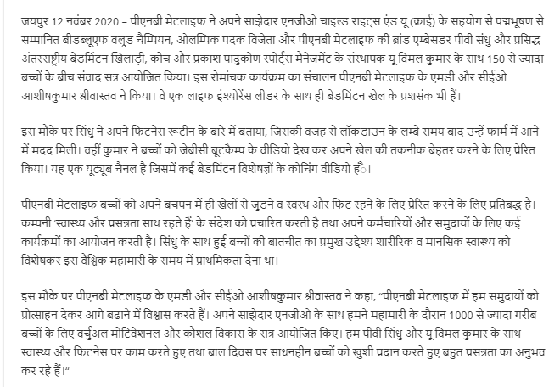

Publication : Patrika Express | Edition : Online
Date : November 13,2020 | Headline: पीएनबी मेटलाइफ की ओर से आयोजित बाल दिवस के कार्यक्रम में पी. वी. सिंधु और यू. विमल कुमार ने बच्चों को बताए फिटनेस और बेडमिंटन के टिप्स


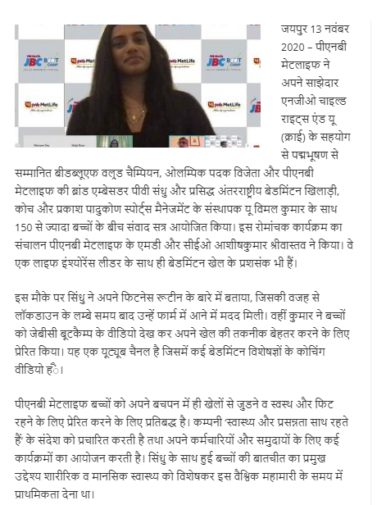

Publication : Society News | Edition : Online
Date : November 13,2020 | Headline: P.V Sindhu and U. Vimal Kumar share fitness and badminton tips with youngsters on children’s day organised by PNB MetLife

Publication : Samnaa Activist | Edition : Online
Date : November 13,2020 | Headline: लाॅकडाउन के लम्बे समय बाद फिटनेस रूटीन से हुई फार्म वापसी : पीवी सिंधु


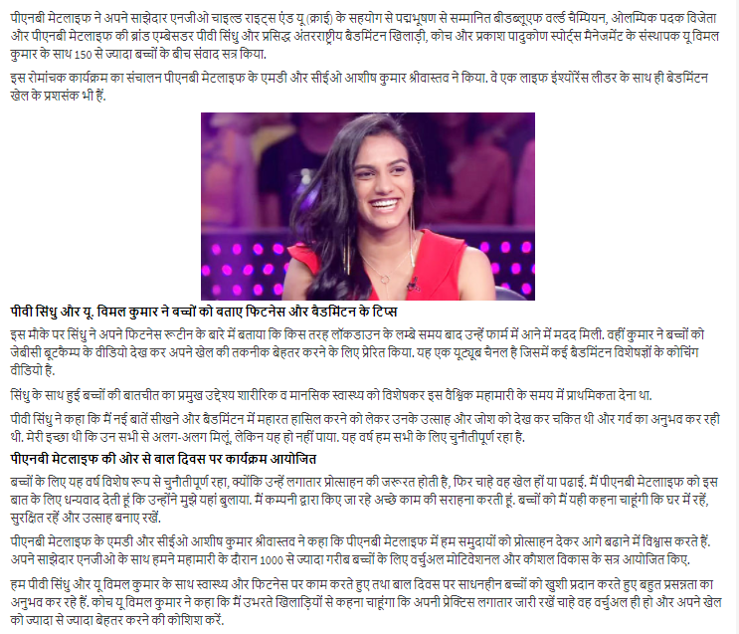

Publication : Western Times | Edition : Online
Date : November 13,2020 | Headline: પી વી સધુઅનેય.ુવમલ ક ુ મારેબાળકાેનેફટનેસ અને બેડમન ટસ અાપી


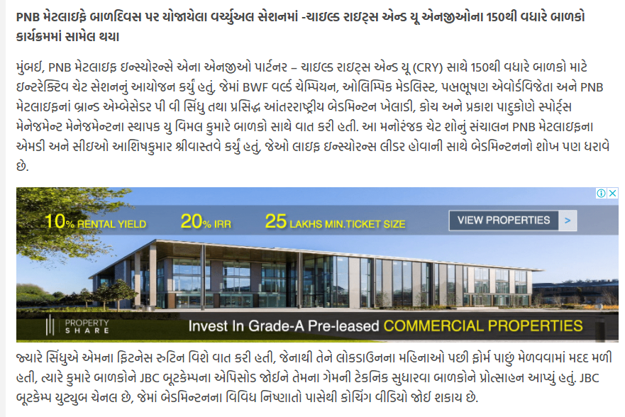
Publication : Efa News | Edition : Online
Date : November 13,2020 | Headline: Children’s Day 2020 – PV Sindhu and U. Vimal Kumar share badminton tips with youngsters


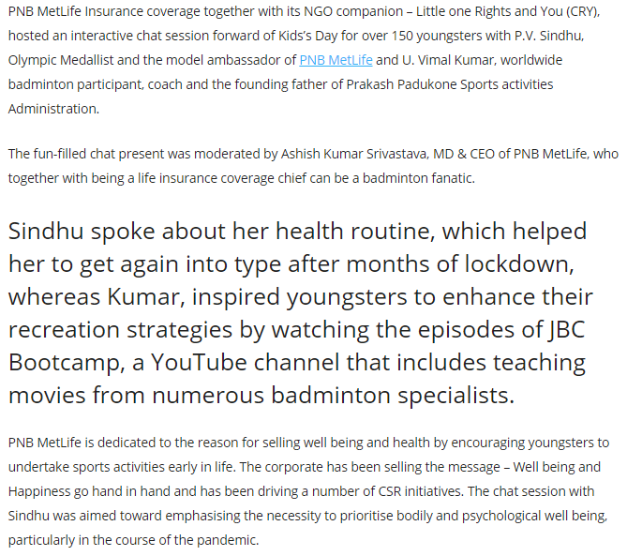

Publication : The CSR Journal | Edition : Online
Date : November 19,2020 | Headline: PNB MetLife distributes hygiene kits under its CSR initiative Damini

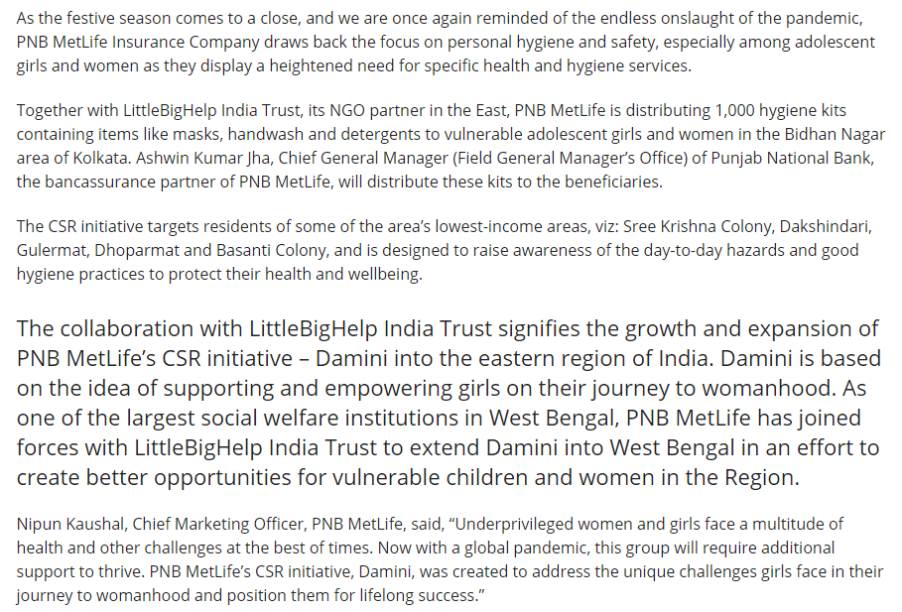


Publication : Sangbad Ekalavya | Edition : Online
Date : November 20,2020 | Headline: PNB MetLife urges adolescent girls and women under its CSR initiative ‘Damini’ to follow hygiene and safety protocols


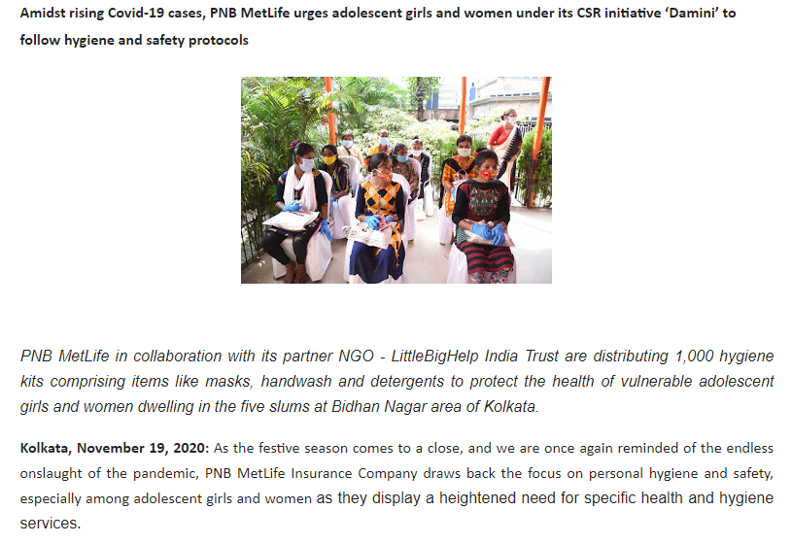

Publication : CSR Times | Edition : Online
Date : November 20,2020 | Headline: PNB MetLife in collaboration with its partner NGO-LittleBigHelp India Trust distributed hygiene kits amidst rising Covid-19 cases


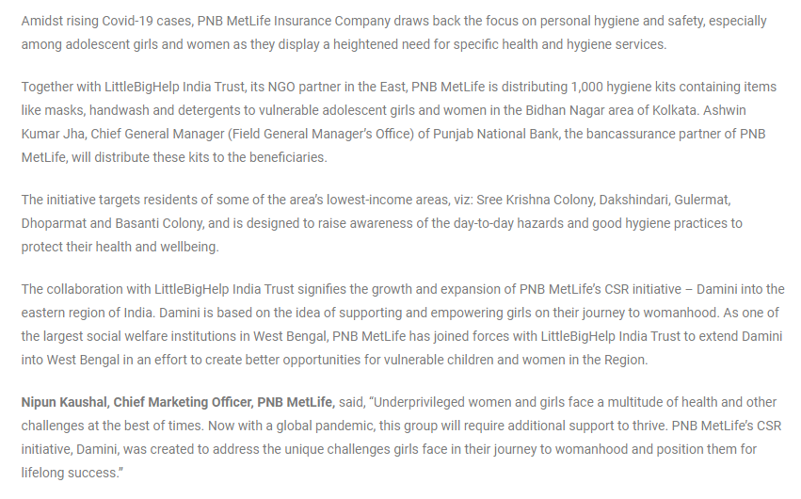

Publication : Adgully | Edition : Online
Date : November 23,2020 | Headline: Searches for insurance products up by 30% in the last 6 months: Nipun Kaushal


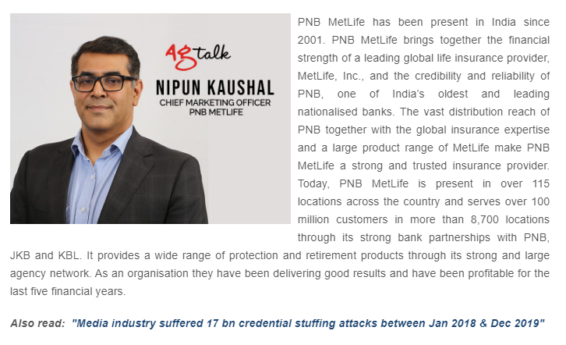

Publication : Mint | Edition : Online
Date : November 24,2020 | Headline: India Post Payments Bank launches Pradhan Mantri Jeevan Jyoti Bima Yojana


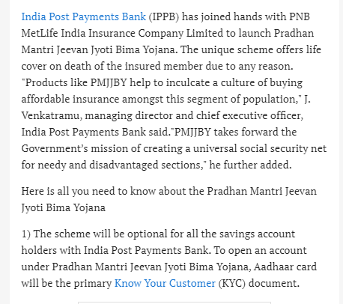

Publication : The Financial Express (Hindi) | Edition : Online
Date : November 24,2020 | Headline: India Post Payments Bank introduced PMJJBY for savings bank customers with PNB MetLife


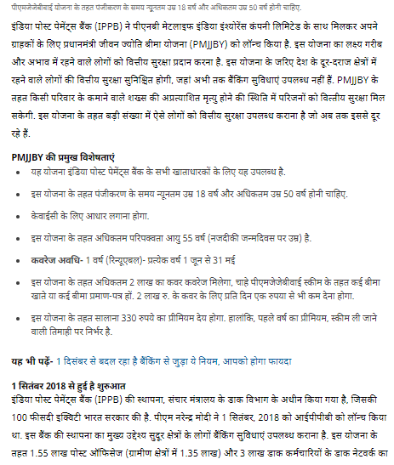

Publication : ET BFSI.com | Edition : Online
Date : November 24,2020 | Headline: IPPB ties-up with PNB MetLife to extend PMJJBY insurance


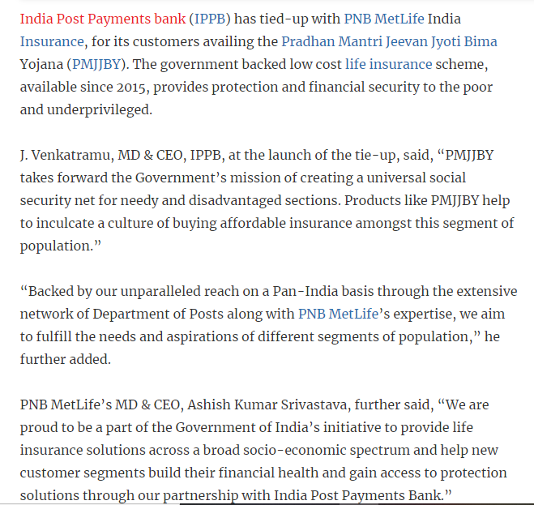

Publication : Timesnownews.com | Edition : Online
Date : November 24,2020 | Headline: India Post Payments Bank introduces Pradhan Mantri Jeevan Jyoti Bima Yojana for savings bank customers


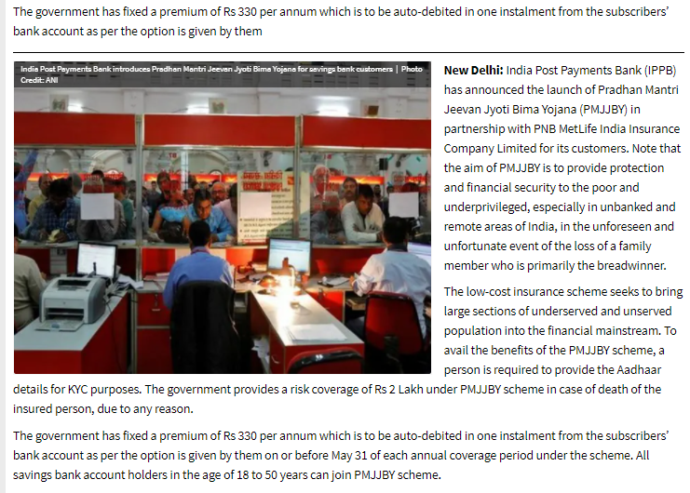

Publication : The Banking & Finance Post | Edition : Online
Date : November 24,2020 | Headline: India Post Payments Bank partners PNB MetLife to launch Pradhan Mantri Jeevan Jyoti Bima Yojana


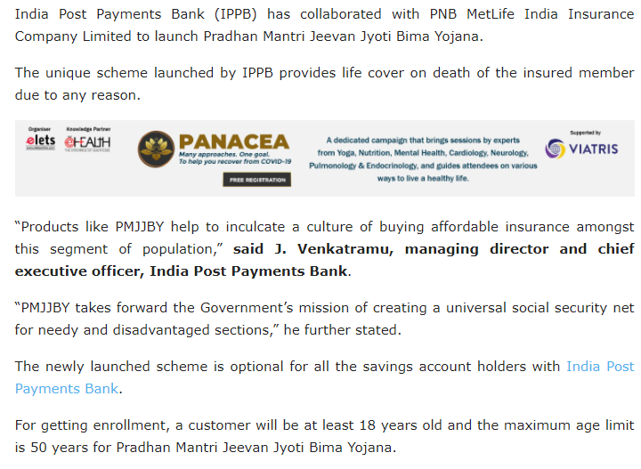

Publication : Asia Insurance Review | Edition : Online
Date : November 24,2020 | Headline: India Insurer donates hygiene kits to low income communities


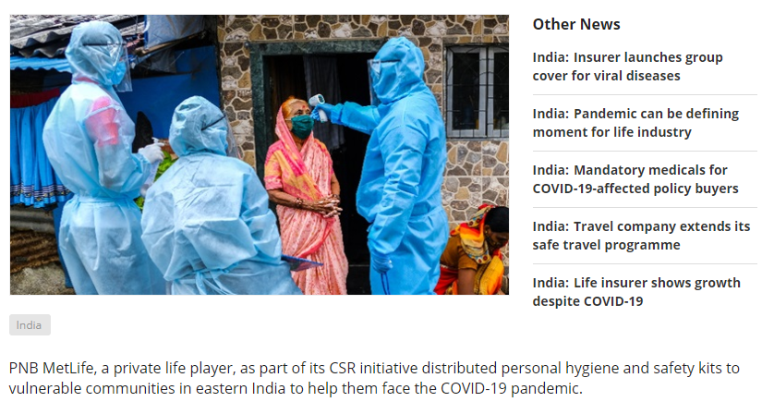

Publication : India Infoline | Edition : Online
Date : November 24,2020 | Headline: India Post Payments Bank introduces Pradhan Mantri Jeevan Jyoti Bima Yojana PMJJBY for customers, inks agreement with PNB MetLife


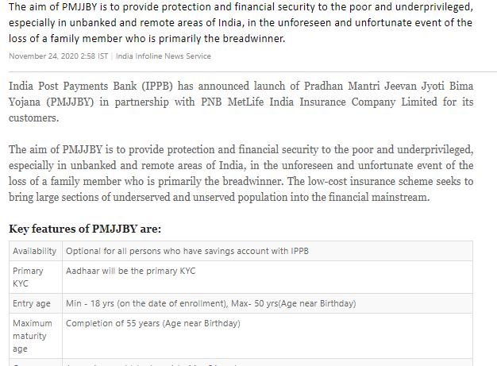

Publication : DNA | Edition : Online
Date : November 25,2020 | Headline: India Post Payments Bank launches Pradhan Mantri Jeevan Jyoti Bima Yojana for account holders


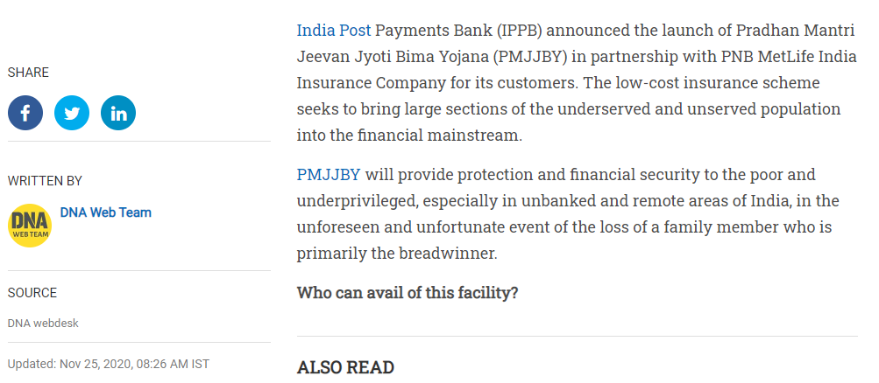

Publication : The News Strike | Edition : Online
Date : November 24,2020 | Headline: India Post Payments Bank introduces Pradhan Mantri Jeevan Jyoti Bima Yojana: PMJJBY


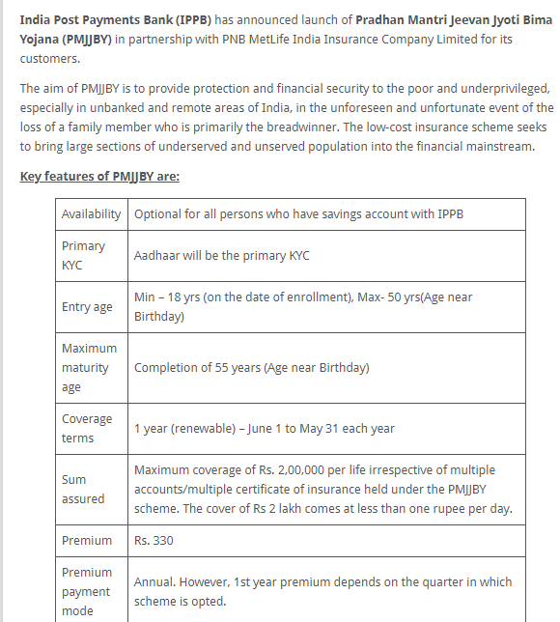

Publication : Odisha Expo | Edition : Online
Date : November 24,2020 | Headline: India Post Payments Bank launches Pradhan Mantri Jeevan Jyoti Bima Yojana for customers


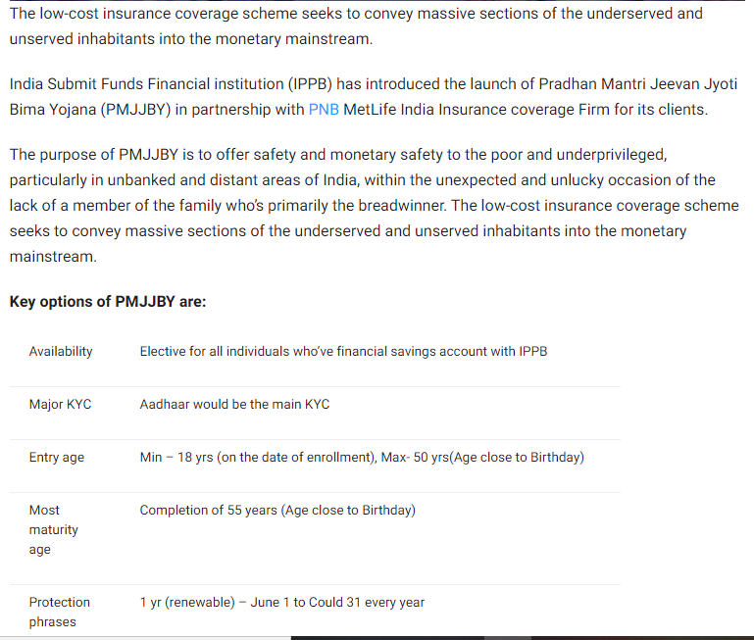

Publication : Catch News | Edition : Online
Date : November 24,2020 | Headline: India Post Payments Bank to provide insurance of Rs 2 lakh for Rs 330. This is how you can avail




Publication : Good Returns (Kannada) | Edition : Online
Date : November 25,2020 | Headline: IPPB launches Pradhan Mantri Jeevan Jyoti Bima Yojana eligibility features other details


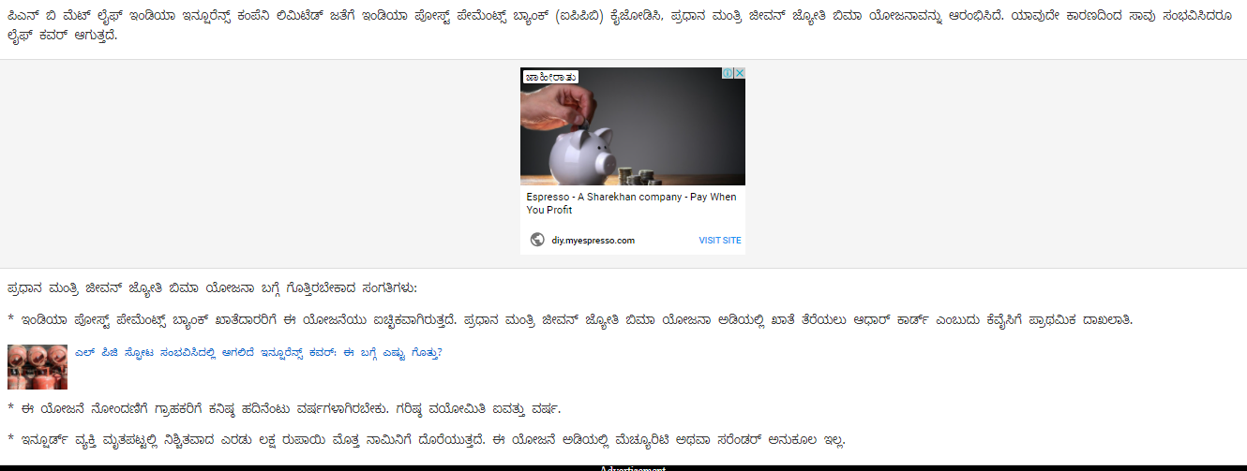

Publication : Just News Day | Edition : Online
Date : November 25,2020 | Headline: India Post Payments Bank launches Pradhan Mantri Jeevan Jyoti Bima Yojana for customers


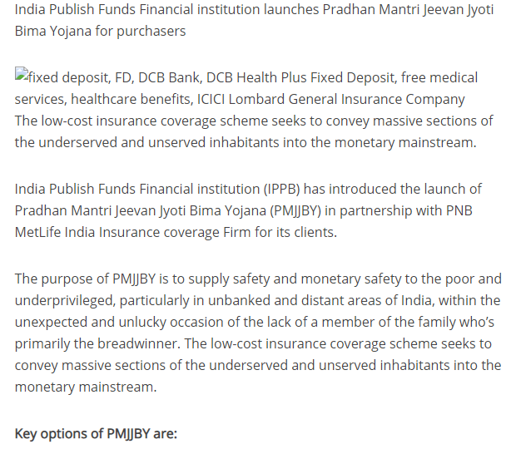

Publication : World News | Edition : Online
Date : November 24,2020 | Headline: India Post Payments Bank launches Pradhan Mantri Jeevan Jyoti Bima Yojana for customers


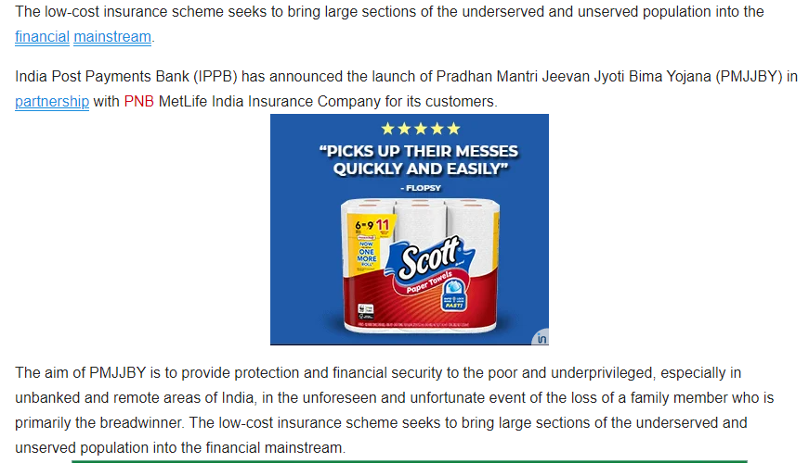

Publication : ABP Live.com | Edition : Online
Date : November 25,2020 | Headline: Post Payments Bank launches Pradhan Mantri Jeevan Jyoti Bima Yojana


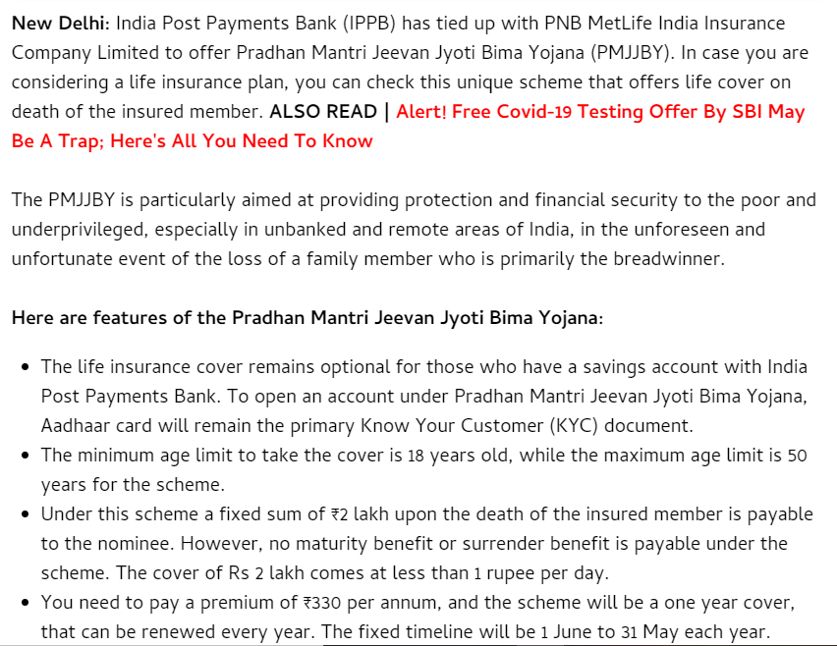

Publication : Affairs Cloud | Edition : Online
Date : November 25,2020 | Headline: IPPB partnered with PNB MetLife India to launch Pradhan Mantri Jeevan Jyoti Bima Yojana


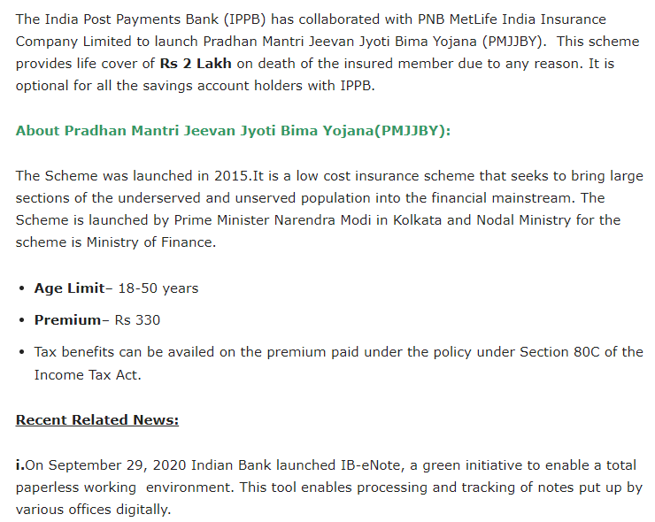

Publication : Informal Newz | Edition : Online
Date : November 25,2020 | Headline: India Post Payments Bank to provide insurance of 2 lakhs for 330 rupees: Know who can get benefit of this


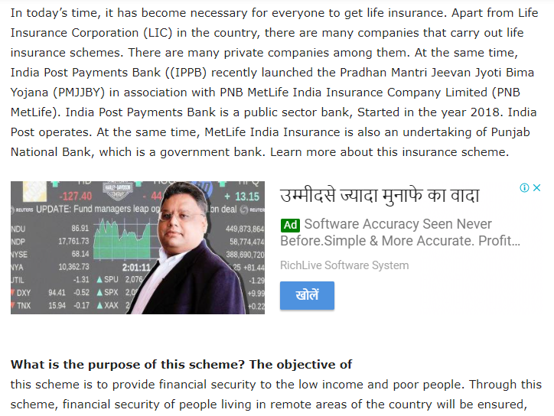

Publication : Byscoop | Edition : Online
Date : November 25,2020 | Headline: India Post Payments Bank launches PMJJBY


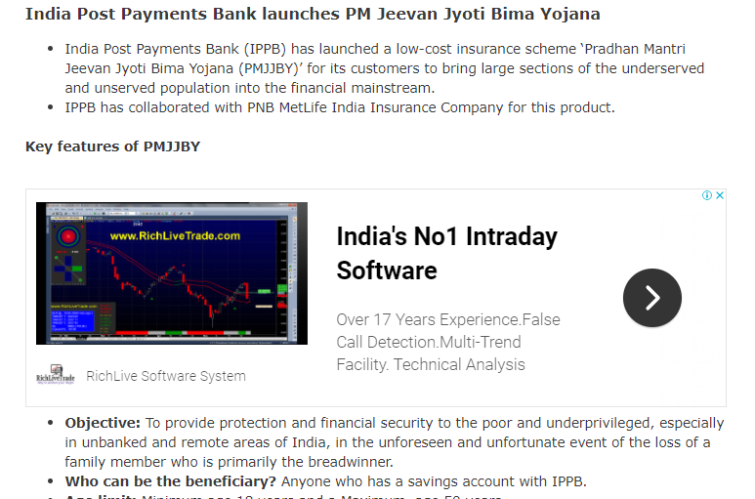

Publication : Business News India | Edition : Online
Date : November 25,2020 | Headline: India Post Payments Bank inks agreement with PNB MetLife


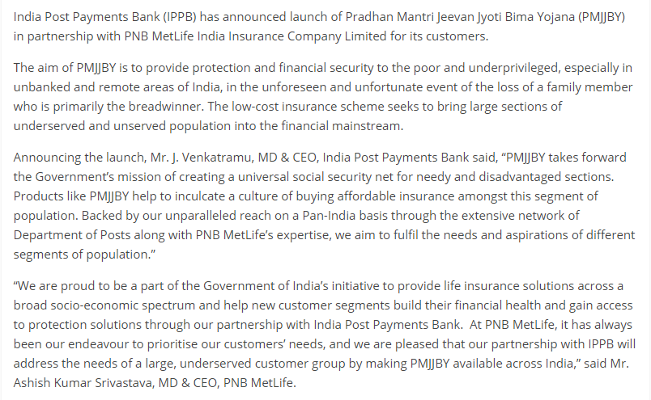

Publication : Times Bhaskar | Edition : Online
Date : November 25,2020 | Headline: India Post Payments Bank Introduces Pradhan Mantri Jeevan Jyoti Bima Yojana (PMJJBY) for Savings Bank Customers, Inks Agreement with PNB MetLife


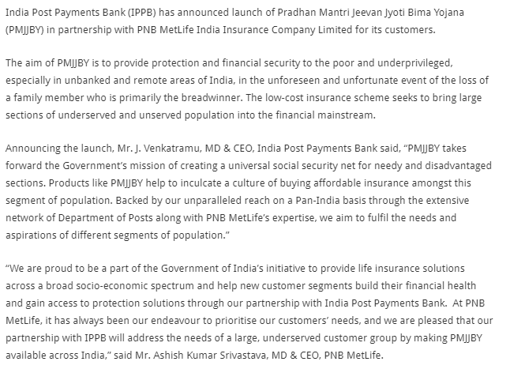

Publication : Gujarat Mirror | Edition : Online
Date : November 25,2020 | Headline: India Post Payments Bank introduces Pradhan Mantri Jeevan Jyoti Bima Yojana


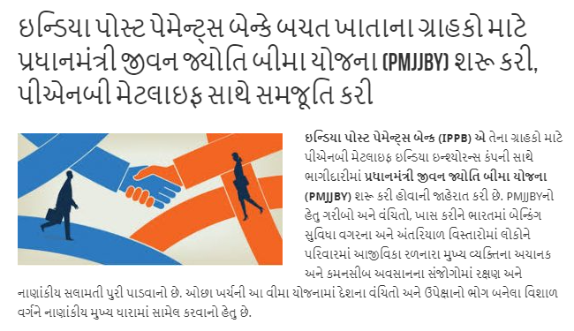

Publication : Asianet News | Edition : Online
Date : November 25,2020 | Headline: India Post Payments Bank introduces PMJJBY for Saving Bank Customers with MetLife


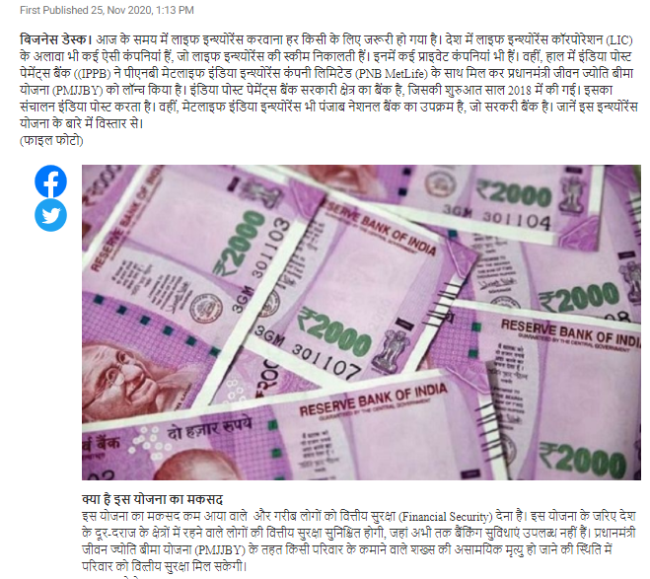

Publication : Fact Report | Edition : Online
Date : November 25,2020 | Headline: Indian Post Payments Bank partners with PNB MetLife


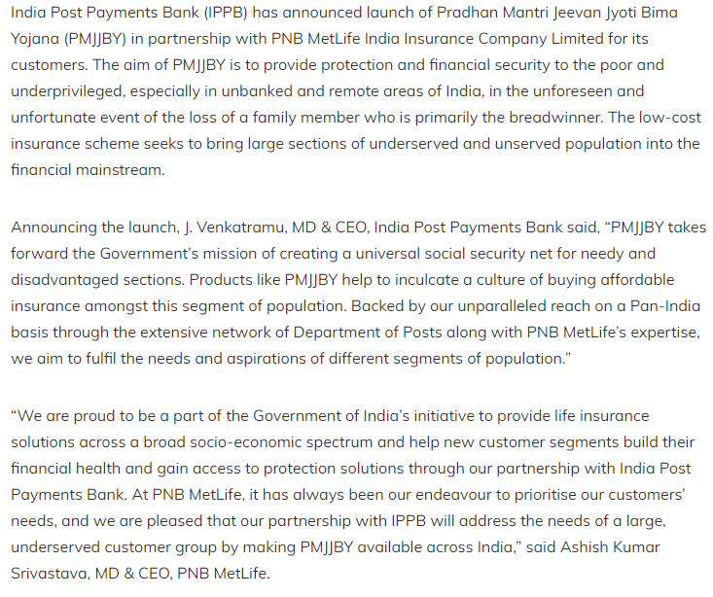

Publication : Prabhat Khabar | Edition : Online
Date : November 26,2020 | Headline: Post Payments Bank launches PMJJBY


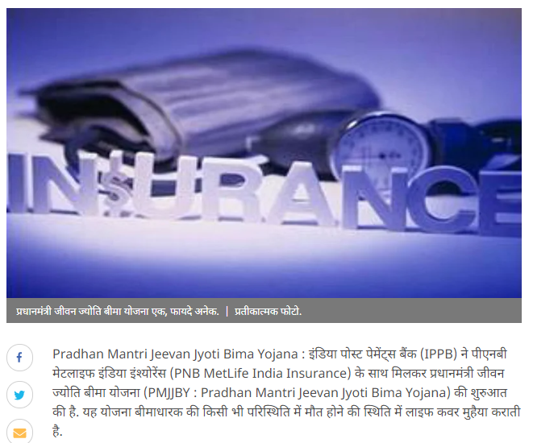

Publication :Live Bharat | Edition : Online
Date : November 26,2020 | Headline: आईपीपीबी ने बचत खाता ग्राहकों के लिए पीएमजेजेबीवाई शुरू किया


